1. What is a call for fire?

A concise message prepared by the observer. It contains all information needed by the FDC to determine the method of target attack.

It is a request for fire, not an order. It must be sent quickly, but clearly so it can be understood, recorded, and read back without error, by the FDC recorder.

2. List the elements in a call for fire.

1. Observer identification.
2. Warning order.
3. Target location.
4. Target description.
5. Method management.
6. Method of fire and control.

3. Regardless of the method of target location used, the normal call for fire is sent in 3 parts consisting of 6 elements.

4. List the element of the call for fire that best describes the definition.

a. If the observer does not accurately describe this, the rounds may not be effective.

Target description.

b. This consists of the type of mission and the size of the element.

Warning order.

c. This is the most important part in the call for fire.

Target location.

d. When used by the observer, this can reduce the sporadic engagement of the target.

Method of fire and control.

e. This element tells the fire direction center who you are.

Observer identification.

5. Write a initial adjust fire request using the following information- you are blue 3, the FDC is red 6, location of target is ZX534678, target is troops in the open, authentication is x-ray, HE in effect.

Red 6, this is Blue 3, adjust fire, over.

Blue 3, this is Red 6, adjust fire, out.

Grid ZX534678, over.

Grid ZX534678, out.

Troops in the open, HE in effect, over.

Troops in the open, HE in effect, Authentication x-ray, out.

I authenticate x-ray, out.

6. Who determines HOW the target will be attacked?

fdc

7. Is direction sent before or with the first subsequent adjustment?

Direction.

8. When sending a grid mission, does the observer’s location need to be known by the FDC?

No it is assumed.

9. The term polar alerts the FDC that the target will be located with respect to what/who’s position?

Respect to the observers position.

10. When sending a polar mission, must the observer’s location be known to the FDC?

Yes.

11. Vertical shifts are sent to the FDC by using the terms Up and Down if the difference between the observer and the target altitude is 35 meters or grater.

12. You are an observer. The FDC knows your location. You see enemy movement on a ridgeline in the open. They are located on an azimuth of 1800 mils and a distance of 3800 meters from your location. Your call sign is Z82 and the FDC is R68. What is your call for fire?

R68, this is Z82, Fire for effect, polar, over.

Z82, this is R68, fire for effect, polar, out.

Direction 1800, distance 3800, over.

Direction 1800, distance 3800, out.

Observer

Target

A

B

C

D

E

___ OT line

___ Vertical shift

___ Range shift

___ Known point

___ Lateral shift

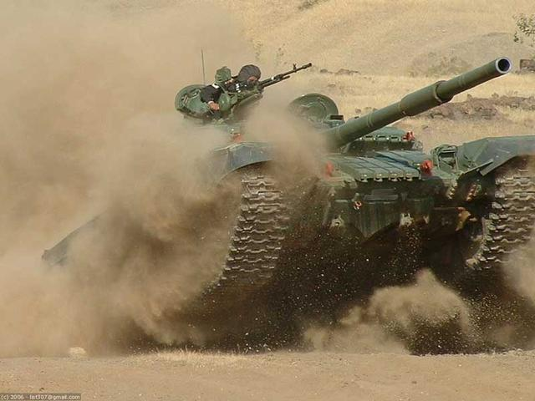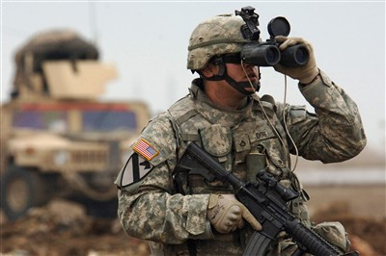

13. For the above graphic list in the space provided the appropriate letter that corresponds to the correct answer.

E

A

D

B

C

14. If a grid call for fire is the standard, what is the most preferred?

Grid

15. When conducting a shift mission the observer does not need a map. What must the observer know?

Only the known point.

16. The lateral shift is a Right or Left correction that brings the round onto the observer target line.

17. The lateral shift determines the straight line distance in meters between the known point and the OT line.

18. Once the lateral shift has been determined, you multiply the shift factor and deviation and is rounded to the nearest 10 meters.

19. The shift factor is the formula used to convert the deviation from mils to meters and brings the strike of the round onto the?

Observer target line.

20. When the deviation is needed quickly you can use the hand method to obtain it.

21. You observe an enemy convoy stopped in the open. They are located 4 fingers to the right and 300 meters above your known point (AC1556). Your direction and distance to your known point is 500 mils and 3400 meters respectively. Your call sign is Z56 and the FDC is N18. What is your call for fire?

500 mils (direction to KP) – 125 (4 fingers right) = 375 mils

3400 (Distance to KP)/1000 (common factor) = 3.4

3.4 x 125 (4 fingers right) = 430

Observer ID and WARNO: N18 this is Z56, adjust fire, shift, AC1556, over.

Target location: Direction 375 mils, Right 430, Add 300, over.

Target description: Enemy convoy in open, over.

22. What is the term used to identify the spot at which the rounds will be more effective?

Adjustment point.

23. Creeping fires are used when the target is?

Danger close.