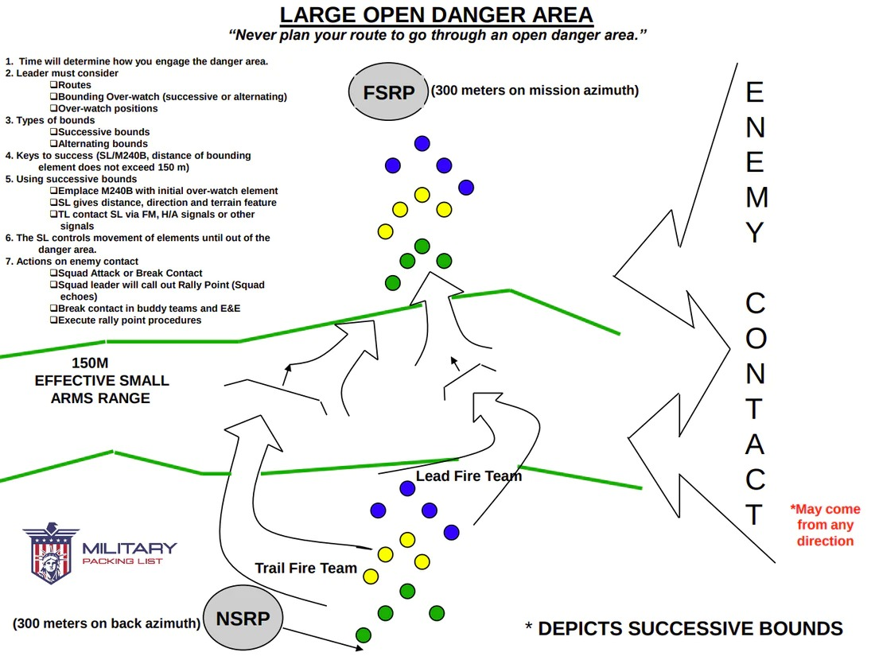

**Crossing a Large Open Danger Area**

The reference for this technique for “Crossing a Large Open Danger Area” can be found on page 6-8 and A-9 of your Ranger Handbook.

Let me introduce you to the “20 Board”. In the center of the board, there is a graphic representation of an open area. The left portion of the board contains administrative notes that will help you follow along. In this depiction the squad, due to time constraints, will utilize the bounding overwatch technique to move through the danger area. **TIME** is the factor that determines whether an open area is small or large and dictates how to negotiate an open danger area. If you have time to bypass the open danger area, it is a small open area, and you will bypass it. (Crossing a Small Open Danger Area can be found [here](https://militarypackinglist.com/blogs/militarypackinglist-blog/crossing-a-small-open-danger-area)) If you do not have time to bypass an open danger area and have to cross through it, then it is a large open area, and you will utilize the bounding overwatch technique. In the center portion of the board there are examples of overwatch positions in the open danger area. The squad takes up these positions as it maneuvers through the open danger area.

At the bottom center portion of the board, there is a **Near Side Rally Point (NSRP)**, which is 300 meters on a  back azimuth from the open area. At the top center point of the board, there is a **Far Side Rally Point (FSRP)** that is 300 meters on mission azimuth from the open area. In this scenario, the squad is traveling to the North or from the bottom of the board to the top.

**OPEN DANGER AREAS**

You should never plan your route to go through an open danger area. Therefore, all open danger areas that you come across during movement are considered unknown. Since the danger area is unknown, the rally points are not planned and are considered "floating" rally points. The near side rally point is 300 meters on a back azimuth and the far side rally point is 300 meters on  mission azimuth for small open danger areas. Keep in mind that the floating rally points are 300 meters from where contact is made with the enemy.

You must avoid all open danger areas. Moving your element through an open danger area greatly increases the chances of making contact with the enemy by direct or indirect fire. The importance of conducting a detailed map reconnaissance of your routes cannot be overstated.

Additionally, **TIME** is the determining factor when deciding if an open danger area is small or large. The time you have available determines how you will negotiate the open danger area.

If you **HAVE TIME** to bypass the open danger area, it is a small open danger area and you bypass it. If you **DO NOT HAVE TIME** to bypass it and must cross the open danger area, it is considered a large open danger area.

For example, let's say that you are patrolling in a wooded area and you come across an open area the size of Fryar Drop Zone. For those of you who are not airborne qualified, Fryar Drop Zone is an open area several kilometers long and wide.

Now if you have the TIME to bypass Fryar Drop Zone, you treat it as a small open danger area. For example,  if you have a whole day to get to the far side, then you treat it as a small open danger area and bypass it using either the contour or detour bypass methods.

However, if you only have 30 minutes to get to the far side of Fryar Drop Zone, you treat it as a large open danger area and use the bounding overwatch movement technique to move across it.

**ACTIONS AT OPEN DANGER AREAS**

Once the lead Team Leader (TL) sees a potential danger area, he gives the hand and arm signal for halt and danger area. To signal “halt,” raise hand to head level, fingers extended and joined. (See example below) To signal “danger area,” draw the right hand, palm down, across the neck in a throat-cutting motion from left to right. (See example below) Next the squad halts, and establishes a 360-degree perimeter in the Short Halt Posture.

-"Halt" Hand and Arm Signal -"Danger Area" Hand and Arm Signal

The SL does a quick visual check to ensure that security is established then moves his way up to the lead  TL’s position.

The lead TL tells the SL why he has halted, for example when there is an open area in front of the squad.

The SL has the squad conduct SLLS to check for any enemy activity in and around the area because an enemy force might be in the area.

The SL and TLs then pinpoint their current location on the map. If the SL understands where the squad is on the map and terrain, he improves his chances of making a sound tactical decision on how to negotiate the danger area. This also helps the SL develop a course of action in the event the squad makes contact with the enemy.  Additionally, pinpointing helps the SL identify if the squad drifted off the planned route and moved to an open area that the SL planned to avoid.

After pinpointing, the SL and lead TL move forward using cover and concealment to avoid detection during  their recon of the potential open danger area. If it is an open danger area, the SL must conduct an assessment and develop a course of action.

The SL must consider:

1. Is this an open danger area?
2. Does he have enough time to move his squad around it? If he does have enough time to move around it, then the squad treats the danger area as a small open danger area. However, if he does not have enough  time to bypass it, he treats it as a large open danger area.

**LARGE OPEN DANGER AREAS**

In this case, the SL determines that his squad does not have enough time to bypass the open area. Since they do not have enough time to bypass it, they must consider it a large open danger area and travel through it utilizing the bounding over watch technique.

**LEADER CONSIDERATIONS**

The SL must decide on the best possible route through the large open danger area. Some of the things the  SL should consider are:

1. A route through the open area that allows the SL to maneuver his fire teams using any available cover and  concealment. He also needs to look for possible low ground such as wadis that his squad could use to avoid detection or defend from in the event they make contact while passing through the open area.
2. He needs to decide which bounding over watch method he wants to use to maneuver his teams through  the open danger area. These are either successive or alternating bounds.
3. The SL needs to determine the route that affords the best possible overwatch positions so that the overwatch team can cover the other team’s movement.

Once the SL determines the best possible route for the squad to travel through the open danger area and  which method of bounds he wants the squad to use, he and the lead TL move back to the squad’s security halt. The  SL briefs his TLs on the course of action he has decided and the TLs disseminate the information to their men.

**SUCCESSIVE VERSUS ALTERNATING BOUNDS**

There are two methods of bounding overwatch. These are alternating and successive bounds. Successive bounds are most preferred. This is because they are easier to control. However, this method of bounding is slower.

Successive bounds are nothing more than putting one team in overwatch and then bounding the other team forward. Once that team is in position and performing overwatch, the other team bounds out and halts online or abreast with the team in overwatch.

This method of bounding online with one another continues all the way across the open area. Generally, the  same team bounds out first each time. Again, it is the easiest method of bounding to control.

Alternating bounds are harder to control. However, you gain more ground quicker. To use alternating bounds one team is placed in overwatch and the other team bounds out and sets up in an overwatch position. Once the bounding team is in position the team that was in overwatch then moves past the team in overwatch. When that team is set in an overwatch position, the team that was in overwatch now moves past the team in overwatch. It is nothing more than leapfrogging your elements across the open area.

For either successive or alternating bounds, there are two keys to success:

1. Both the SL and M240B gun team usually stay with the initial overwatch element and they remain with  that element throughout the movement unless otherwise dictated by the SL due to METT-TC considerations (Learn about METT-TC [here](https://militarypackinglist.com/blogs/militarypackinglist-blog/applying-mett-tc-at-ranger-school)).
2. The bounding element does not bound more than the direct line of sight and effective small arms range of the element in the overwatch position. Therefore, the teams should not bound more than 150 meters from one another. This is all METT-TC dependent. Remember that effective small arms range is 300 meters, but if the bounding team goes that far, the supporting team cannot effectively engage any enemy forces beyond them.

**USING SUCCESSIVE BOUNDS**

Since successive bounds are the most preferred method to use; therefore, I will talk you through crossing the large open danger area using successive bounds.

Once the SL determines where and how he wants to cross the large open danger area he positions a team in the wood line in an overwatch position. The example on the 20 board shows the lead team in the initial overwatch position. This team is preferably in the prone (situation dictates), prepared to engage the enemy and covers the movement of the trail team into the open area.

The SL positions the M240B gun team with the initial overwatch element. Keep in mind that the SL can  keep the M240B with the initial overwatch element throughout the movement.

Once that team is in the overwatch position, the SL then gives a distance, direction and if available a  prominent feature for the bounding team to move to. In this example, the initial maneuver element is the trail team. The trail team bounds out to the position the SL designates and sets up an overwatch position. As the team bounds out, they move in a team wedge and are prepared to make contact. Once this maneuver element establishes an overwatch position, the TL tells the SL his team is prepared to perform overwatch duties. The TL can communicate this by calling on FM, using hand and arm signals, or using any other predetermined signal.

The SL then gives a distance, direction and prominent feature to the TL from the original overwatch  position. The squad on the 20 board is using the successive bounding method. When successive bounding, the maneuvering team moves to a position that is online (abreast) with the other team. In the example on the board, the lead team moves online with the trail team.

The SL continues to maneuver his teams through the open danger area in this manner until the squad reaches the wood line on the far side of the open area. Once the squad is in the wood line, they return to the FOOM (Formations and Order of Movement) and continue with the mission. (Learn about FOOM [here](https://militarypackinglist.com/blogs/militarypackinglist-blog/formations-and-order-of-movement))

**Note:**If you are moving through an open danger area and you come across a road in the middle of the open area, consider this a danger area within a danger area. You will continue to move in successive or alternating bounds.

**ACTIONS ON ENEMY CONTACT**

The most important element when in contact with the enemy is to maintain control. Contact can be made anywhere in or around the open danger area. If contact is made while crossing an open danger area, regardless of its size, the SL must maintain control of his squad. It is up to the SL to determine whether to conduct a Squad Attack or Break Contact.

If the squad is in contact and the SL loses control of his Squad, perhaps due to an overwhelming enemy force:

1. The SL calls out which Rally Point best facilitates the squad's survival and mission completion.
2. The entire squad echoes the designated rally point.
3. The squad then breaks contact by buddy teams and E&E (Escape and Evade) to the designated rally point.
4. At the rally point, they conduct rally point procedures.

While breaking contact and moving towards the rally point, the squad members need to get out of the open danger area as soon as possible. If they are in the wood line, they need to ensure that they do not enter the open danger area while moving to the rally point.

This was a summary of how you will be expected to cross large open danger areas at Ranger and Sapper School.

You can continue learning by reading about Crossing a Linear Danger Area.