

X J

X K

Map is for test purposes only! This map is not approved for fires or actual land navigation.

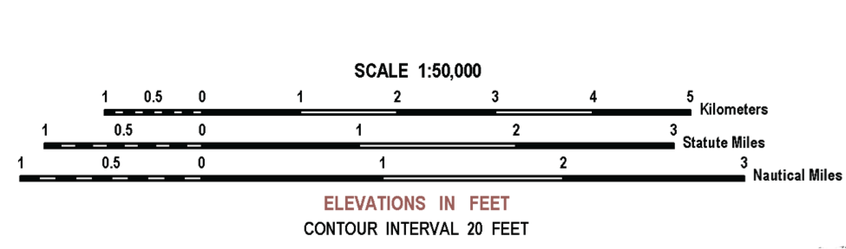

ELEVATION IN FEET CONTOUR INTERVAL 20 FEET

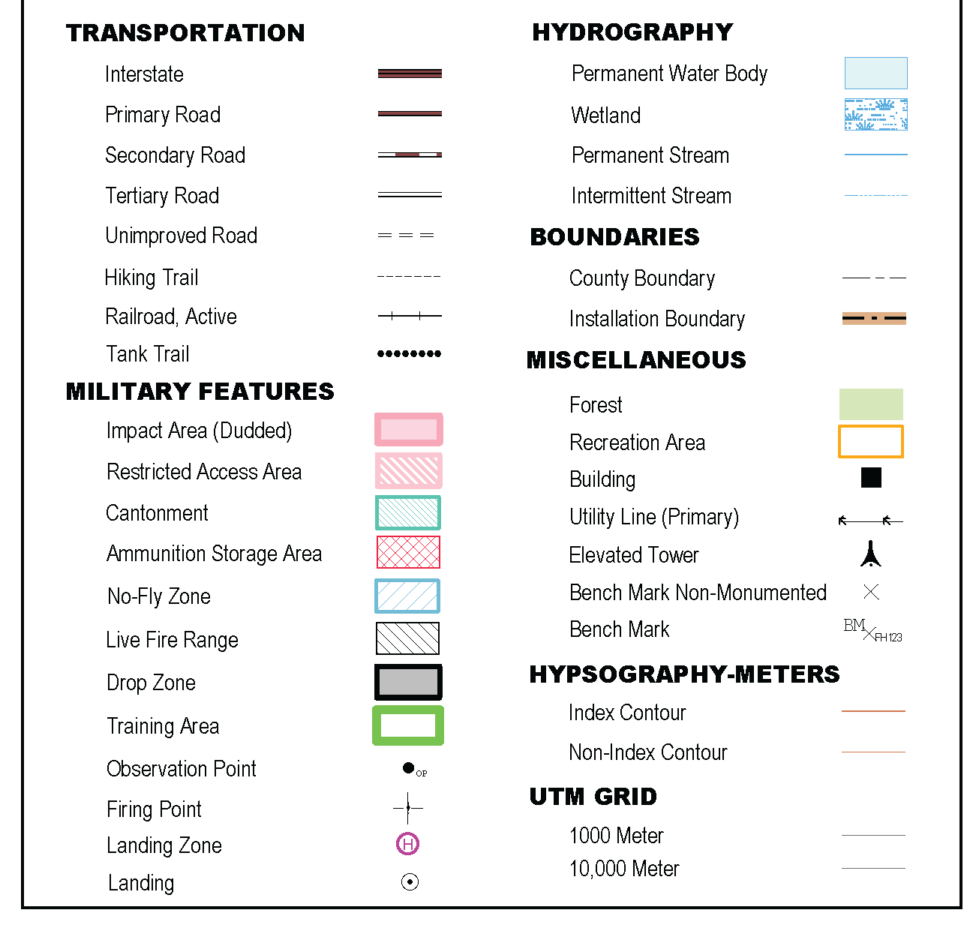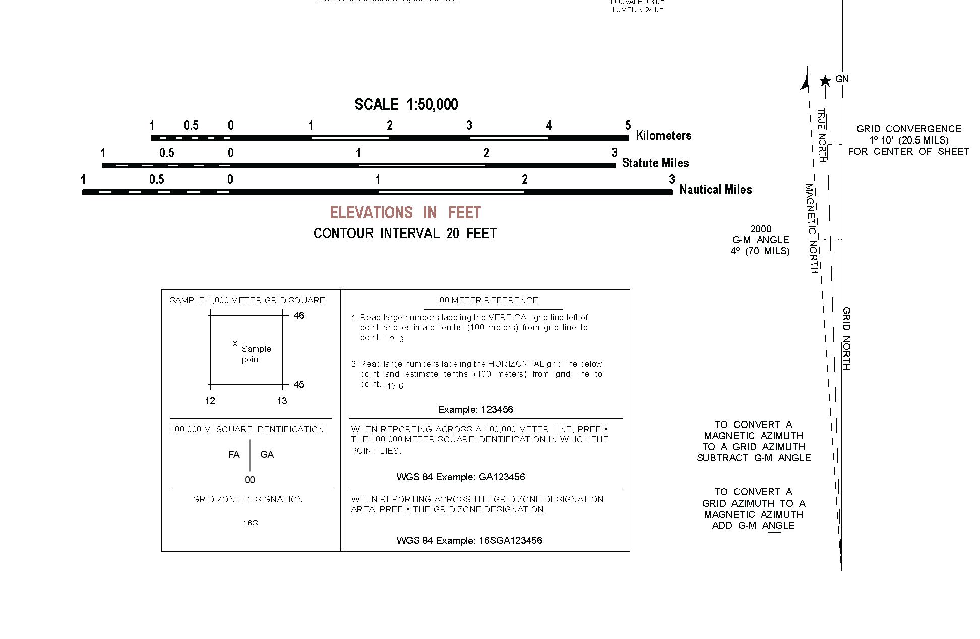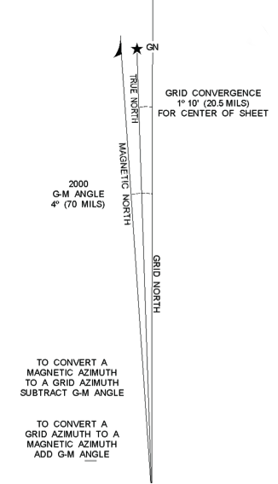

1. The grid for point J is ____________.
   1. 76509825 b. 98257650 c. 76509825 d. 98757605
2. The grid coordinate for point A is _____________.
   1. 76459959 b. 99557672 c. 99597645 d. 99587645
3. The grid for point K is _____________.
   1. 02307835 b. 78350230 c. 78350230 d. 02307835
4. The straight line distance between point A and point B is ______ meters.
   1. 5000 b. 3700 c. 3000 d. 4250
5. To move from point A to point B, you moved on a grid azimuth of _______ degrees.
   1. 62 b. 55 c. 250 d. 243
6. To move from point A to point B, you moved on a magnetic azimuth of _______ degrees.
   1. 246 b. 51 c. 254 d. 66
7. At point B, the grid coordinate is ______________.
   1. 02747806 b. 02307810 c. 02307810 d. 78050230
8. You observe point C. What type of terrain feature are you looking at?
   1. ridge b. depression c. saddle d. spur
9. What is the grid coordinate of point C?
   1. 00257820 b. 77100080 c. 00257820 d. 00767715
10. You been moved to point D. You are now in/on a _______________.
    1. draw b. cliff c. valley d. ridgeline
11. From point D, how far is point C?
    1. 2000 feet b. 2500 feet c. 2500 meters d. 2000 meters
12. What is the magnetic azimuth you need to follow to reach point E from point D?
    1. 97 degrees b. 115 degrees c. 105 degrees d. 280 degrees
13. Point E is in/on a __________.
    1. depression b. valley c. saddle d. draw
14. What is located at GA00127485?
    1. building b. Point D c. pond d. elevated tower
15. The red-brown lines at point E are __________________.
    1. vegetation b. a manmade object c. contour lines d. small trail
16. Describe the stream at point E?
    1. intermittent b. permanent c. large creek d. small creek

1. If you move 4550 meters on a grid azimuth of 326 degrees from point H, what terrain feature do you find?
   1. ridge b. valley c. saddle d. spur
2. What is the terrain feature at point B?
   1. fill b. cliff c. draw d. hill
3. What is the grid azimuth between points F and point G?
   1. 115 degrees b 104 degrees c. 95 degrees d. 284 degrees
4. You have been told to observe point C from point H. What terrain feature is point H?
   1. depression b. spur c. valley d. cliff
5. From point H, you pull out your compass and look at point C. What is the azimuth?
   1. 320 degrees b. 316 degrees c. 312 degrees d. 137 degrees
6. What is your location at point H?
   1. 01207610 b. 01887611 c. 01207610 d. 76100120

Question Answer

1 b

2 c

3 c

4 a

5 b

6 a

7 d

8 c

9 a

10 b

11 d

12 d

13 c

14 c

15 d

16 b

17 c

18 a

19 c

20 d

21 b

22 a

23 a

24 b

25 d

Question Topic Areas

Terrain Features 6

Azimuth 6

Plotting 7

General Map (Legend) 3

Distance 3

Elevation 2

Answer Frequency

a a 6

b b 6

c c 7

d d 6