Name

Roster #:

Date:

1. What are the three components of weapons handling?
2. The soldier, The weapon, The environment
3. The shot process, The soldier, The weapon
4. Stability, Aim, Control
5. Weapons hold, Weapons tight, Weapons free
6. Which is not one of the 8 cycles of function for the M4 carbine?
7. Firing
8. Unlocking
9. Extracting
10. Unloading
11. What are the 3 stages of ballistics?
12. Internal, Terminal, External
13. Internal, External, Vertical
14. External, Terminal, Support
15. Stability, Control, Movement
16. Which is not one of the 4 functions of stability?
17. Muscle relaxation
18. Natural point of aim
19. Support
20. Movement
21. Which one is part of the aiming process?
22. Sight picture
23. Optic
24. Zeroing
25. Weapons status
26. What are the movement techniques? circle all that apply
27. Vertical
28. Retrograde
29. Horizontal
30. Forward
31. What are the functional elements of the shot process? Circle all that apply
32. Stability
33. Aim
34. Control
35. Movement
36. All the above

1. The basic outline of an individual engagement sequences all firers consider during an engagement, regardless of the weapon employed is known as what?
2. Line of sight
3. The shot process
4. Stability
5. Line of bore
6. Which answer is the functional elements of the shot process?
7. Stability, Aim, Control, Movement
8. Stability, Aim, Engage, Detect
9. Stability, Aim, Recoil recovery, Time
10. Stability, Aim, Movement, Sight picture
11. What weapon safety status is Red?
12. The weapon’s magazine is inserted, a round is in the chamber, the bolt is forward and locked, the ejection port cover is closed, and the selector is set to SAFE
13. A magazine is locked in the magazine well, the bolt is forward with a Round chambered, the ejection port cover is CLOSED or OPEN, Selector is on Fire and the Shooter’s Finger is on the Trigger because they have initiated their Shot Process
14. The weapon’s magazine is removed, its chamber is empty, its bolt is locked open or forward, and the selector is set to SAFE
15. A magazine is locked into the magazine well of the weapon, the bolt is forward on an EMPTY chamber, the ejection port cover should be CLOSED, and the selector should be set to SAFE
16. Weapons hold is best defined as?
17. Engage only if engaged or ordered to engage.
18. Engage only if target is positively identified as enemy.
19. Engage targets not positively identified as friendly.
20. All of the above
21. What is rule one of firearm safety?
22. Never point the weapon at anything you do not intend to destroy
23. Treat every weapon as if it is loaded
24. Keep finger straight and off the trigger until ready to fire
25. Ensure positive identification of the target and its surroundings
26. What must you do for immediate action?
27. Slap, Pull, Observe, Release, Tap, Squeeze
28. Slap, Tap, Rack, Fire
29. Tap, Rack, Reassess
30. Rack, Tap, Bang
31. What is the max range of the M4 carbine?
32. 3200M
33. 3600M
34. 3500M
35. 2500M
36. What is the max effective range of an area target?
37. 300M
38. 600M
39. 700M
40. 500m
41. What is the max effective range of a point target?
42. 500M
43. 400M
44. 600M
45. 300M

1. What part of the weapon is shown below?

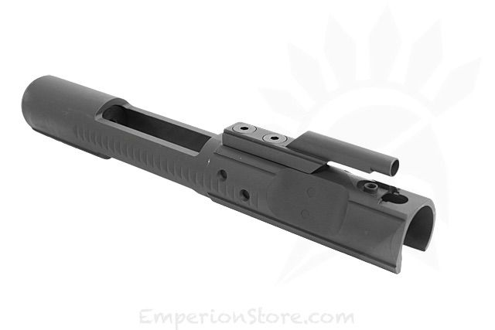

1. Bolt carrier
2. Bolt
3. Lower receiver
4. Slip ring
5. What part of the weapon is shown below?

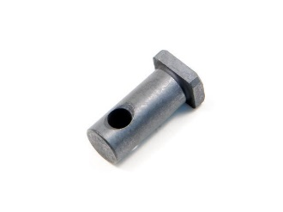

1. Bolt cam pin
2. Firing pin
3. Firing pin retaining
4. Extractor
5. What part of the weapon is shown below?

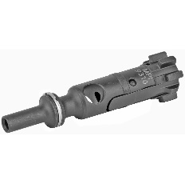

1. Bolt
2. Bolt Carrier
3. Extractor
4. Firing pin
5. What part of the weapon is shown below?

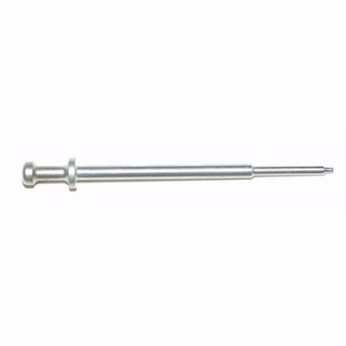

1. Extractor
2. Firing pin
3. Retaining pin
4. Bolt
5. When the weapon is placed on the sand bag this provides what?

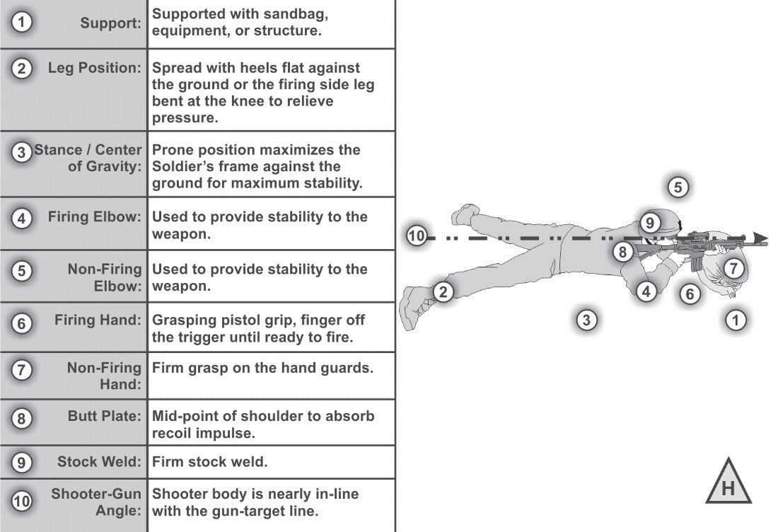

1. Stability
2. Aim
3. Line of sight
4. Sight picture
5. In the picture below the target should be what?

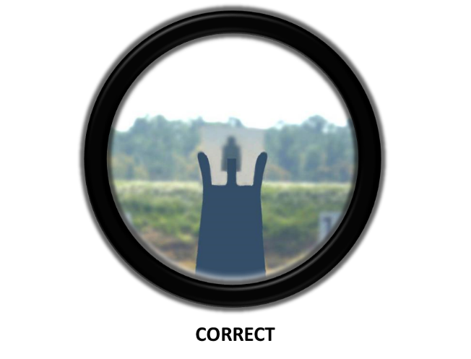

1. Blurry
2. Easily seen
3. Hard to see
4. All the above
5. This is called your what?

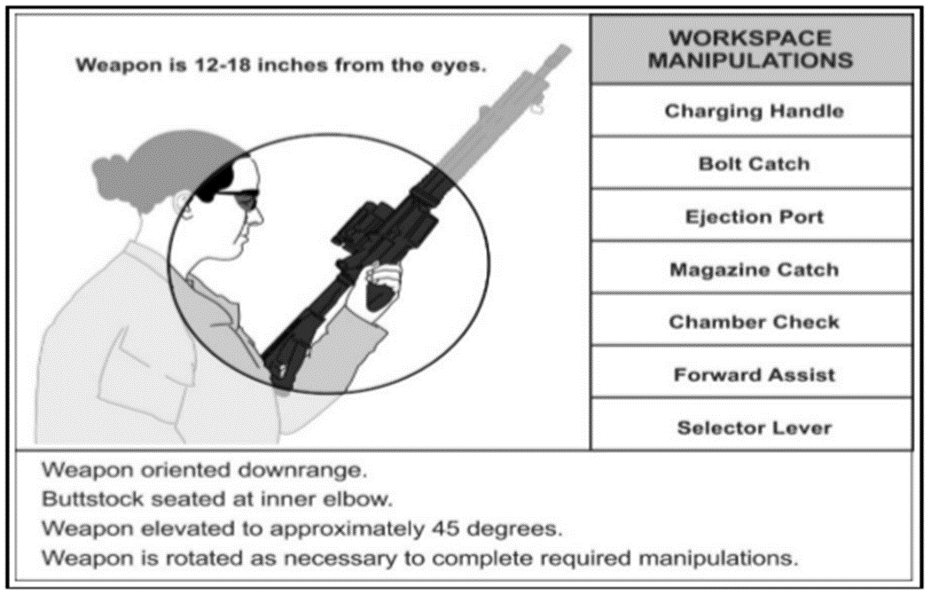

1. Work space
2. Loading you magazine
3. Unloading your magazine
4. Checking your sights
5. The firing hand must be placed where? #6

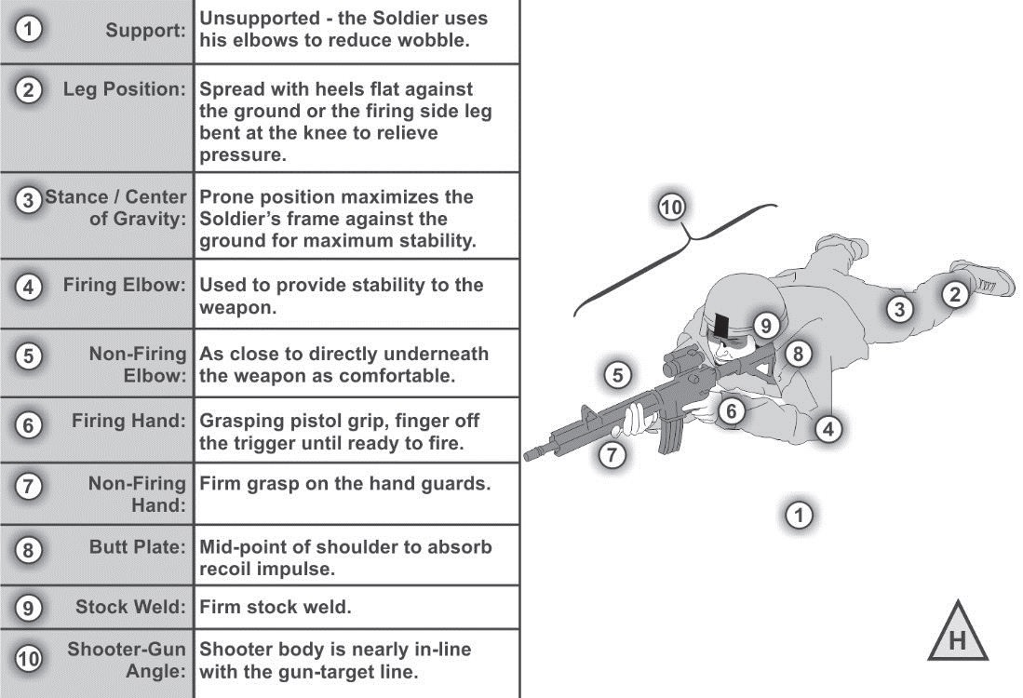

1. High and tight on the pistol grip
2. Hand clinched around pistol grip with finger on trigger
3. Hand tiled around pistol grip for better support
4. Hand around pistol grip with the thumb pointing up
5. What must be done once the M4 carbine is reassembled?
6. Get ready to turn weapon in
7. Perform a functions check
8. Clean outside of weapon
9. Check the sights for alignment