1. What is a call for fire? ____________________________________________________________________________________________________________________________________________________________________________________________________________________________________________________________________________________________________________________________________________________

2. List the elements in a call for fire. ____________________________________________________________________________________________________________________________________________________________________________________________________________________________________________________________________________________________________________________________________________________

3. Regardless of the method of target location used, the normal call for fire is sent in ____ parts consisting of ____ elements.

4. List the element of the call for fire that best describes the definition.

a. If the observer does not accurately describe this, the rounds may not be effective. ______________________________________________________________________________

b. This consists of the type of mission and the size of the element. ______________________________________________________________________________

c. This is the most important part in the call for fire.___________________________________

d. When used by the observer, this can reduce the sporadic engagement of the target. ______________________________________________________________________________

c. This element tells the fire direction center who you are. ______________________________

5. Write a initial adjust fire request using the following information- you are blue 3, the FDC is red 6, location of target is ZX534678, target is troops in the open, authentication is x-ray, HE in effect. _________________________________________________________________________________________________________________________________________________________________________________________________________________________________________________________________________________________________________________________________________________________________________________________________________________________________________

6. Who determines HOW the target will be attacked? _________________________________________

7. Is direction sent before or with the first subsequent adjustment? _____________________________

8. When sending a grid mission, does the observer’s location need to be known by the FDC? _________

9. The term polar alerts the FDC that the target will be located with respect to what/who’s position? _____________________________________________________________________________________

10. When sending a polar mission, must the observer’s location be known to the FDC? _____________

11. Vertical shifts are sent to the FDC by using the terms ______ and ______ if the difference between the observer and the target altitude is _____ meters or grater.

12. You are an observer. The FDC knows your location. You see enemy movement on a ridgeline in the open. They are located on an azimuth of 1800 mils and a distance of 3800 meters from your location. Your call sign is Z82 and the FDC is R68. What is your call for fire? _________________________________________________________________________________________________________________________________________________________________________________________________________________________________________________________________________________________________________________________________________________________________________________________________________________________________________

Observer

Target

A

B

C

D

E

___ OT line

___ Vertical shift

___ Range shift

___ Known point

___ Lateral shift

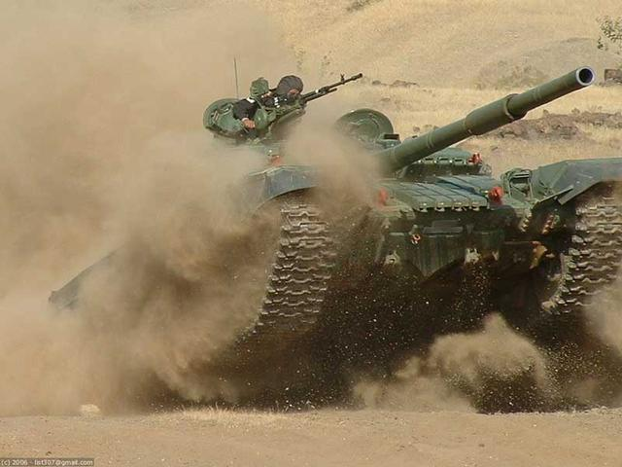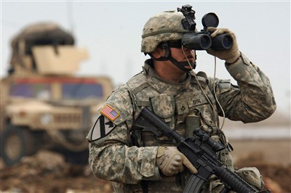

13. For the above graphic list in the space provided the appropriate letter that corresponds to the correct answer.

14. If a grid call for fire is the standard, what is the most preferred? _______________________________

15. When conducting a shift mission the observer does not need a map. What must the observer know? _______________________________________________________________________________

16. The lateral shift is a _________ or __________ correction that brings the round onto the observer target line.

17. The lateral shift determines the straight line distance in meters between the ___________________ and the _____________________.

18. Once the lateral shift has been determined, you multiply the ______________ and ______________ and is rounded to the nearest ______ meters.

19. The shift factor is the formula used to convert the deviation from mils to meters and brings the strike of the round onto the _____________________________________________________________.

20. When the deviation is needed quickly you can use the ___________ method to obtain it.

21. You observe an enemy convoy stopped in the open. They are located 4 fingers to the right and 300 meters above your known point (AC1556). Your direction and distance to your known point is 500 mils and 3400 meters respectively. Your call sign is Z56 and the FDC is N18. What is your call for fire? _________________________________________________________________________________________________________________________________________________________________________________________________________________________________________________________________________________________________________________________________________________________________________________________________________________________________________

22. What is the term used to identify the spot at which the rounds will be more effective? _____________________________________________________________________________________

23. Creeping fires are used when the target is _______________________________________________