School of Command Preparation (SCP)

Company Commander/First Sergeant Course (CCFSC)

Lesson Plan 158-SCP0003
Command Climate

Course Manager: Mr. Marvin McGee, School of Command Preparation (SCP), marvin.h.mcgee.civ@mail.mil
Lesson Author: Mr. Mounir Bouchareb, Center for the Army Profession and Leadership (CAPL),
Date Prepared: March 2022

1. SCOPE
This is a two-hour lesson that supports the Company Commander/First Sergeant Pre-Command Course. This lesson is intended to prepare company commanders and first sergeants to assume their roles and responsibilities as part of a command team. The outcome of this lesson is for Company Commanders and First Sergeants to understand the importance of establishing a positive command climate in relation to command responsibility.

2. LEARNING OBJECTIVES

Action: Examine command climate.

Conditions: As an incoming company commander or first sergeant attending the pre-command course; given classroom instruction, peer-to-peer discussion, instructor feedback, reflection time, and references such as AR 600-20, ADP 6-22, and FM 6-22; and Building and Maintaining a Positive Climate Handbook.
Standard:
- Distinguish at least three elements between command climate and organizational culture.
- Identify at least three ways that command climate may affect unit performance.
- Explain at least three individual Soldier behaviors that may affect command climate.
- Review the Army requirement for the Defense Organizational Climate Survey (DEOCS) in a clear and concise manner.
Learning Domain: Cognitive

Level of Learning: Analysis

- ASSIGNED STUDENT READINGS:

Prior to class read:
- AR 600-20, Army Command Policy (July 2020)
  - Appendix E: Command Climate Assessment (1 page)
- Building and Maintaining a Positive Climate Handbook (July 2020)
  - Read Chapter 4 Assessing an Organization’s Climate (page 10-19)
  - Read Chapter 5 Developing a Plan to Improve Climate (page 20-35)
  - Read Chapter 6 Implementing the Plan for Change (page 38-40).

- FACILITATOR ADDITIONAL READING(S)/MATERIAL:

Instructor must provide the materials and appropriate references to the students. Additionally, instructors should be familiar with the following references.

ADP 6-22, Army Leadership and the Profession (Change 1, November 2019)
AR 600-20, Army Command Policy (July 2020)
AR 600-100, Army Profession and Leadership Policy (April 2017)
AR 350-1, Army Training and Leader Development (December 2017)
Army People Strategy – Diversity, Equity, and Inclusion Annex (September 2020)

- TRAINING AIDS, REFERENCES AND RESOURCES

- Lesson plan slides (separate file)
- Maps: N/A
- Videos: DEOCS videos are available online.
- Computer and projection systems for presenting PowerPoint slides.
- White Board with dry erase markers and eraser, and/or butcher block paper and markers.

- CONDUCT OF LESSON

a. Lesson timeline with learning step activities (LSAs):

First Hour:
10 minutes Concrete Experience and Publish and Process
40 minutes LSA 1 - Review of climate and culture, command climate, leader effectiveness, individual Soldier behavior and command climate and the DEOCS requirement.
10 minutes Break
Second Hour:
25 minutes LSA 2 – Factors of a command climate.
20 minutes LSA 3 - Discussion/practical exercise (PE) questions and review of the company commander and 1SG relationship.
5 minutes Reflection/Summary

b. Lesson Appendices – None

Slide 1 – Lesson Title – Command Climate
Facilitator actions:  Introduce the class to the students. | 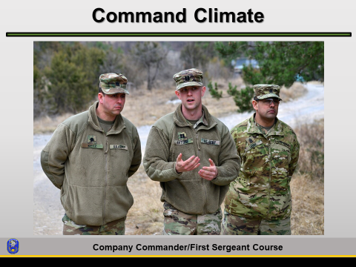

Facilitator notes: One of the duties of the company commander and 1SG is to provide their Soldiers an environment that creates a sense of inclusion. They must facilitate an atmosphere of trust and cohesion, resulting in productive team members. Establishing a positive command climate, as it relates to command responsibilities, is both an art and a science. You are going into a position of command because you have shown you have the maturity, ability, strength, and wisdom to command and/or assume first sergeant duties and responsibilities. The Army has confidence that you will train, equip, care about, and take care of your Soldiers. There are many requirements on both commanders and 1SGs. The biggest requirement, and some say the most challenging and rewarding, is to establish and maintain a positive command climate. Many things go into this and none stand-alone. This is why it is BOTH an art and science. You must allow your Soldiers to try and fail so they can learn, but eventually hold them to meeting the standards of competence dictated by their position, experience, and training. You must maintain wellness, enthusiasm, and pride in the unit, community, and families. It is your duty to set and maintain the highest standards of training and readiness. You must provide coherent, productive, ethical leadership to all and provide a climate of professionalism, free of racial, religious, sexual orientation, and gender bias. Among all of these things, you will find in a positive command climate a clear, widely known purpose. It has well-trained and confident Soldiers. It also has disciplined cohesive teams that have trusted competent leaders.

Slide 2 – Terminal Learning Objective (TLO)
Facilitator actions: Briefly cover the learning objectives.  Then transition to the first topic for the class. | 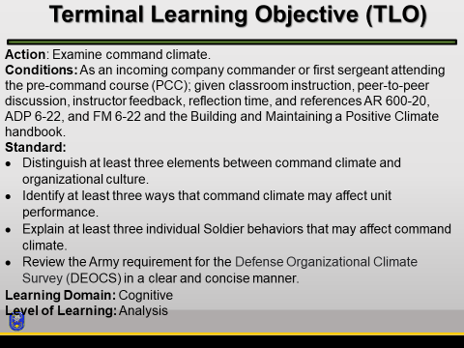

Slide 3 – Concrete experience
Concrete Experience (CE): Use the information as a concrete experience.  Before playing the movie, provide students with some context about the scene by reading the short synopsis below. | 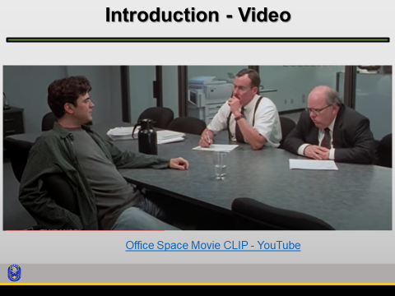

Facilitator notes: Before playing the movie, provide students with some context about the scene by reading this short synopsis.

Peter is a computer programmer working for Initech in Houston. Every day, he and his friends Samir and Michael Bolton suffer endless indignities and humiliations in their workspace from their boss. For Peter, every day is worse than the one before it. To make things worse, the company is in the process of downsizing and has hired two consultants to identify individuals that will be fired. In this scene, Peter has a candid discussion about his typical work day, with these two consultants.

Office Space Movie CLIP - Motivation Problems - YouTube https://www.youtube.com/watch?v=cgg9byUy-V4&list=RD3vdcw415OcQ&index=7

Play the video then ask the following questions:

- Have you ever felt this way?

- How would you describe Peter’s attitude at this junction?
  - Feel free to discuss body language, overall attitude and mental state.

- Speculate as to some possible reasons for his behavior and attitude.
  - Does Peter appear to be disgruntled, disengaged or apathetic, or disingenuous?

- How would you gauge the psychological health of the organization and its members?
  - Is this a good forum to use to gather feedback?

Facilitate the conversation toward these key topics:
- Establish and communicate a clear vision
- Avoid micromanaging
- Focus on the activities that matter
- Take time to connect
- Address problems directly and quickly
- Create an energizing work environment
- Be a catalyst for change

Slide 4 – Culture and Climate
Facilitator actions: Compare and contrast culture and climate with the class.  Students have seen this before in earlier courses such as BOLC and CCC. | 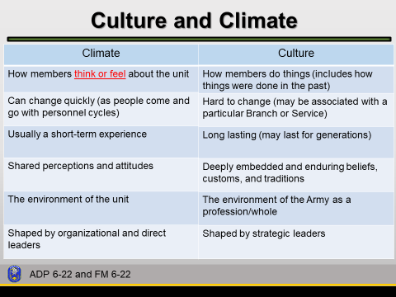

Facilitator notes: Let’s look at the difference between these two terms and then focus on the area where you will have more influence as a company-grade leader – climate.

Instructor asks the question first, listens to discussion, and shows slide after.

Possible Discussion Questions:
- What is the difference between culture and climate?
- As a commander, how can you influence your organization’s climate?
- Is it possible to influence a unit’s culture?
- Can the Army’s culture change over time?

It’s important to define culture and climate, because not only is it an environment in which a leader leads, but is also a medium that leaders can mold both directly and indirectly.

Culture consists of shared values, beliefs, behaviors and norms that characterize the larger institution over time and is embedded in tradition. On the other hand, climate focuses on how people think and feel about their organization, based on shared perceptions and attitudes. Therefore, it’s critical to strive for a positive climate and make certain that Soldiers and DA Civilians feel part of the team and contribute to the effort, while demonstrating respect at all times. Reference: ADP 6-22 para 6-21 thru 6-23

Check on Learning

Question: What is climate?
Answer: Climate is a shorter-term experience than culture and reflects how people think and feel about their organization (ADP 6-22 para 6-23).

Question: What is culture?
Answer: Culture consists of shared attitudes, values, goals, and practices that characterize the larger institution over time (ADP 6-22 para 6-22).
Slide 5 – Command Climate
Facilitator actions: Every commander expects to have a healthy command climate and a cohesive unit.  The Army – your Soldiers – and each of you are expected to create or contribute to environments promoting growth and development whether deployed or in garrison. | 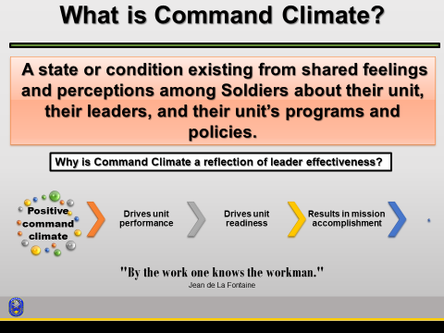

Facilitator notes:
Doctrine does not have an official definition for command climate.
A state or condition existing from shared feelings and perceptions among Soldiers about their unit, about their leaders, and about their units programs and policies.

Why is command climate important?
A positive command climate drives unit performance, drives unit readiness, and results in mission accomplishment.

End the discussion by commenting on the quote by the French poet, Jean de La Fontaine. A commander/1SGs’ unit is a direct reflection of his/her work ethic and character.

For more information on Jean de La Fontaine, see https://www.britannica.com/biography/Jean-de-La-Fontaine

Slide 6 – Leader Effectiveness
Facilitator actions: Effective leaders model the positive behaviors they want others to emulate.  Reference: Building and Maintaining a Positive Climate Handbook, pages 7 and 8. | 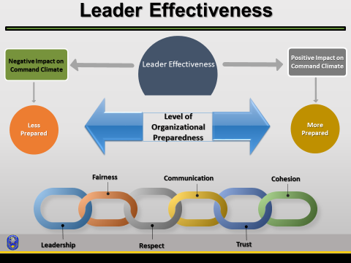

How is this condition created?
By the commander, and continually shaped by his/her own actions and those of their subordinates. Effective leaders model the positive behaviors they want others to emulate, such as leadership, fairness, respect, setting the example, communication, trust and cohesion.
How does character play a role in creating this condition?
Displaying Character. Leaders can display character by modeling standards for performance, completing tasks on time, personal appearance, physical fitness, and ethics. They can also display character by modeling sound judgement and reasoning, determination, persistence, and patience.

Slide 7 – Individual Soldier Behavior and Command Climate
Facilitator actions: Although subordinate leader effectiveness affects command climate – so too do individual Soldier behaviors. | 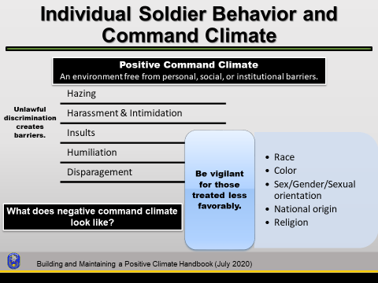

Facilitator notes: A commander requires the right information to make the best possible decisions. As a commander, you need to envision what a positive command climate looks like and the steps necessary to eradicate the barriers that prevent it from being so. Instructor should allow students to brainstorm through each barrier and try to identify the source, after asking the following question:

Why is it important to talk about discriminatory behavior at the unit level?
Company commanders and 1SGs must be willing to discuss discrimination with their troops. This is an ugly topic, but leaders cannot shirk away from the challenge. Confronting this behavior head-on creates mutual respect, trust, and transparency. Commanders and 1SGs must have a “zero tolerance” policy for destructive behaviors that contribute to a negative command climate.

What does negative command climate look like?
The topics of discussion should revolve around the at-risk populations, and the steps a commander can take to protect them from these barriers.

As a command team, you must be able to identify the characteristics of a positive command climate. You must also be able to recognize some actions that you can take that leads to a positive command climate. Taking care of people and maximizing their performance largely determines how well the leader shapes the organization’s climate. Climate is how members feel about the organization and comes from shared perceptions and attitudes about the unit’s daily functioning. Climate affects motivation and the trust Soldiers and Army Civilians feel for their team and leaders. Climate is generally a short-term experience, depending upon a network of personalities within the organization that changes as people come and go.

Why does it take courage to create a learning environment?
A learning environment requires courage because you must be willing to challenge old paradigms (i.e., the old ways of thinking, doing business, solving problems, and approaching issues). Learning leaders use their experience to find better ways of doing things. Leaders dedicated to a learning environment cannot be afraid to challenge how they and their organizations operate. When leaders ask, “why do we do it this way” and find the reason is, “because we’ve always done it that way,” it is time for a closer look at the process. Unless leaders are willing to question how things operate now, no one will know what is possible. Hence, by following old paradigms, a leader unknowingly may be limiting their unit’s potential.

Describe a strategy that has helped you create change. What were some of the challenges you faced?
Leaders who make it a priority to improve their subordinates lead learning organizations. They use effective assessment and training methods, motivate others to develop themselves, and help others obtain training and education to reach their potential. An upbeat climate encourages individuals to recognize the need for organizational change and supports a willing attitude of learning to work with change.

Slide 8 – Determine the Health of an Organization.
Facilitator actions: The first thing you will do is identify what needs improvement. | 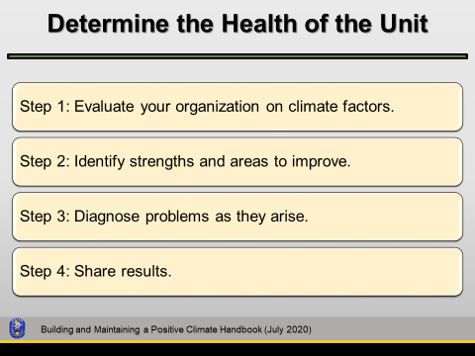

Facilitator notes: Part of being a steward of the profession is policing one’s self and others in the organization. Leaders need to continually assess the organizational climate, realize the importance of development, and work to limit any zero-defect mentality. Recognizing the importance of long-term sustainability and sharing and encouraging feedback (both positive and negative) needs to be a priority for all unit members.

The first thing you will do is identify what needs improvement. AR 600-20 requires commanders to conduct a Department of Defense Command Climate Assessment Survey. A MEO professional will work with you and serve as the Command Climate Assessment Survey administrator. A MEO professional is an EO PM, EO SGM, EO advisor or EO specialist (RA/USAR) assigned to brigade level and higher organizations. Your company level EO Leader (EOL) may assist but the survey administrator must be an EO Professional. Review the results of your Command Climate Survey and focus group results. You have already analyzed the data, which gives you identification of areas that need improvement. Sometimes these areas are something that you can directly affect and others are areas that you may have to rely on others. The point is that you owe it to your Soldiers to do everything in your power to address those issues that affect the command climate. You may have to talk to outside agencies or senior officers in the chain of command about certain issues.

To create a positive climate, leaders have the challenge to identify the presence and effects of anyone who contributes to a negative climate. Some techniques for doing this include—
- Augmenting evaluations with information from peer and subordinate perspectives.
- Pursuing both evaluative and developmental approaches to correct negative behaviors.
- Using unit climate assessment reports to identify problems early.
- Focusing on long-term success by recognizing legitimate concerns from subordinates and making timely and candid feedback part of a leader’s routine responsibility.

Never forget that your command climate has a huge impact on unit motivation. If there is a general feeling of cohesion, trust, and esprit de corps, your Soldiers will be motivated to achieve higher standards that not only you set for them, but also those they set for themselves. A motivated unit in a positive command climate is a force to be reckoned with. They will train harder, faster, and achieve more than those with a mediocre command climate.

Shared perceptions and attitudes about daily unit functions can give you an idea of the overarching tone of your command climate. In all units, you will invariably have the one or two subordinates that are unhappy no matter how good or productive the climate of the command is. However, if you see things like dips in performance or other behavioral indicators we discussed earlier – you need to get to the root cause of those behaviors and perceptions.” One of the tools at your disposal is the Defense Organizational Climate Survey, often referred to as DEOCS.

Slide 9 – Assessment Methods
Facilitator actions: Refer to AR 600-20 Appendix E: Command Climate Assessment. | 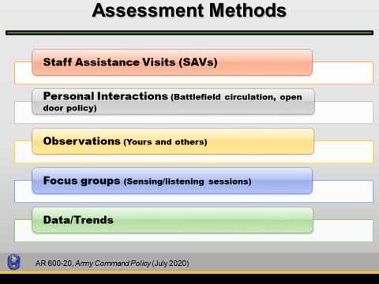

Facilitator notes: Before addressing the topic of assessment methods, determine if students have some prior knowledge on the issue.

Question: What are some other ways to assess your unit’s climate?
The survey is only one component of a CCA. A commander has many assessment tools available to gauge their unit’s command climate. Using several tools allows leaders to triangulate the data between methods to get a more accurate view of the unit. These other methods can also be used as a stand-alone for a pulse check between annual requirements.

Staff Assistance Visits (SAVs)
The SAVs provide commanders/SROs an overall assessment of their command climate. Commanders/SROs and MEO professionals will conduct SAV’s at every command/organization level, on an annual basis.

Interviews
Conducting interviews is an integral part of command climate assessments. Commanders/SROs and MEO professionals will consider the best interview method when gathering data, such as individual interviews, focus groups, or group interviews.

Observations
Personal observation by the organizational leader gathers additional climate information that may impact personnel and the unit. Observations are a method for viewing unit members performing daily activities in their natural work environment. Some of the difficulties in doing an observation are being focused on the task, being attentive to your surroundings, remaining unbiased, and making note of things for further retrospect and analysis. To gain a better understanding on how to plan and conduct your unit observation visit deocs.net under Phase 3 to view the Observation video and guide.

Focus groups
Focus groups are a form of group interviews to gather specific information about the unit or given command. They may be formal or informal events conducted by the chain of command or other staff personnel. However, they are most effective when participants are free to discuss their feelings and share their opinions about the organization. A commander may elect to conduct a focus group during any phase of the assessment process. Focus groups are an excellent tool for clarifying the cause and effect relationship between survey findings and organizational practices. Through focus groups, commanders learn which specific events or unit activities induce both favorable and unfavorable responses by participants. Focus groups cannot offer the level of anonymity that surveys or interviews provide. To avoid issues of intimidation or reprisals, commanders are encouraged to conduct focus groups among a sampling of Soldiers from similar peer groups such as junior enlisted, junior NCOs, senior NCOs, and officers. Additional information on planning and conducting focus groups is contained at in TC 26-6 Appendix F.

Trends
Records and reports are used by units to document a variety of organizational actions and processes and provide a wealth of information regarding trends and indicators which contribute to the overall health of the organization. Some of the detailed data to review may include EO/EEO complaints, awards (including monetary and nonmonetary), selection for special training, punishments, separations, promotions, etc. For more information on how to correlate this information view the Records and Reports guide and video at deocs.net under Phase 3.

These discussion questions will help reinforce the need for having many tools that can assist a commander in determining the overall health of the unit:

- What assessment methods would be most effective in defeating the different filters that may plague an organization? Consider the fact that Organizational climate surveys can be narrow in scope, focusing mainly on SHARP and EO issues. Examples:
- Commander can add tailored questions, based on the organization’s needs
- Personal engagement - observations
- Interviews and focus groups

- How will you prioritize the usage of these assessment methods, as you advance in your career?

- Where else might battlefield circulation fit in?

Slide 10 – DEOCS and the DEOMI Website
Facilitator actions: Use the DEOMI website to guide the class discussion.  https://www.defenseculture.mil//  or to go directly to Assessments to Solutions  https://www.defenseculture.mil/Assessment-to-Solutions/A2S-Home/  Address the command climate requirements. | 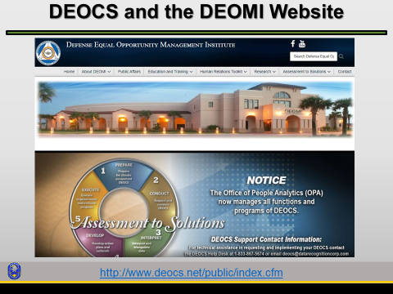

Facilitator notes: Before delving into command climate surveys and DEOCS, ask students these questions. The questions below are meant to create a discussion about the fact that this is a DoD and AR 600-20 mandate, but more importantly to illustrate that this assessment tool allows you to gauge what your predecessor has left behind. Remind leaders that ultimately, the result of which would not be a reflection on them.

- Why do you think the DoD and HQDA mandate command climate surveys?
- Who thinks this is a relatively new requirement?

Command climate surveys are a required part of command and are covered in AR 600-20 [refer to para 6-5, appendix E1 and E2] for RA and USAR and NGR 600-21 for ARNG.
- Your initial Command Climate Survey must be done within 60 days of assuming command.
- Army National Guard and U.S. Army Reserve commanders must conduct a Command Climate Survey within the first 120 days of assuming command.
- Reserve component and active component commanders must conduct subsequent assessments 12 months later and annually thereafter while retaining command.
- Both active and reserve assessments must include a facilitated small group discussion.
- It is recommended that at least two assessments methods be used to complement the survey and verify its indicators to get a complete picture of the unit climate (a comprehensive assessment).

The DEOCS website provides key information in preparing for the survey and summarizes the planning considerations for using the other assessment methods. Additionally, in the Assessment to Solutions text field of the DEOMI website, there is specific information about the DEOCS, its components, and how to order one for your unit.

Facilitator note: While at the Assessment to Solutions page, point out the videos that can be downloaded for review. The Assessment In-Brief will give students a good idea what to expect from the EO professional in preparing for the survey. Other videos and guides include Focus Group, Observation, Record Review, Individual Interview, Develop and Execute action plans.

After the command climate survey closes, the commander and EO professional will analyze the survey results. Survey responses will be systematically collated and analyzed, and used to create an executive summary of the data. The executive summary must include significant findings, organizational strengths and areas of concerns. The action plan describes the commander's planned corrective actions. The requesting commander must brief the next higher-level commander on the results of the command climate assessment, including the action plan, no later than 30 days after completion of the assessment.

Note: The action plan will include (for each area of concern found):
1. Survey area of concern
2. Finding(s)
3. Correction action

Command climate assessment information is now in para 6-5, appendix E1 and E2 (requirements and explanation of terms).

Slide 11 – Command Climate Navigator
The Command Climate Navigator (CCN) is an online lesson that provides interactive multimedia instruction (IMI) using data input from the DEOCS.  This IMI resource helps company commanders and senior NCOs build more positive command climates in order to increase unit effectiveness. | 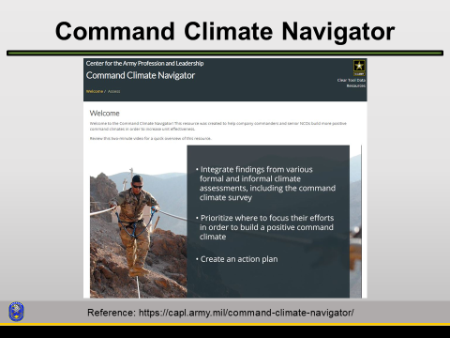

Note: Currently, the Command Climate Navigator is being redesigned and may not fully align with the DEOCS.

*** BREAK: End of first hour. Allow students to take a ten-minute break.

Slide 12 – Influencing Positive Command Climate
Facilitator actions: The following factors are essential in creating a rich and sustainable command climate that creates integration and cohesion. At the tip of this process is leadership.  Instructors should spend ~ 20-25 minutes discussing this slide. | 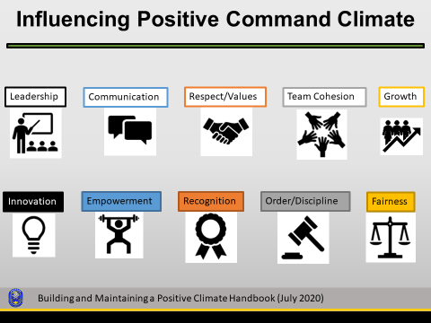

Facilitator notes: Once commanders understand the current state of their command climate, they can develop a plan to both build on areas of strength and improve areas of weakness. These are some strategies a commander can use to reach that goal.

Leadership: Be authentic and true to yourself, be a catalyst for change, build your self-awareness, establish clear goals and objectives and consider the impact of previous commanders.

Communication: Practice transparency by sharing information, use feedback to reinforce desired behaviors, allow members to share their perspective and act on feedback.

Respect/Values: Model the Army values, treat people with courtesy, politeness, and kindness and hold everyone accountable.

Team Cohesion: Set up opportunities for the team to socialize, create transparency in decisions and actions, encourage the team to share best practices, harness conflict by exploring opposing viewpoints, and celebrate team accomplishments.

Growth/Development: Develop others (coaching, mentoring, career programs) and empower subordinates through delegation.

Innovation/Adaptability: Reinforce creative ideas, allow flexibility in how goals are met, question assumptions and play devil’s advocate.

Empowerment: Allow members to practice decision-making, invite them to advise on important decisions and provide constructive feedback.

Recognition: Use healthy competition and leverage multiple resources.

Order/Discipline: Demonstrate self-discipline, consistently enforce standards, and set clear expectations.

Fairness: Encourage and support diversity and inclusiveness and remain objective.

Often, leaders must juggle facts, questionable data, and intuitive feelings to arrive at a quality decision. Good judgment informs the best decisions for the situation and is a key attribute of transforming knowledge into understanding and quality execution. In other words, you have to use your own judgment in identifying some of the trends. You will also have to use your judgment in deciding how to address whatever the results of your assessment might be. Regardless of what you decide to address or do, you must be careful to not over or under react. A leader that over-reacts to a situation does not instill confidence in his subordinates in his ability to command. You must make measured changes or actions appropriate to the trend you see. A danger of under-reaction is that your subordinates feel that their opinions and needs are not being addressed. This is not good for a positive command climate either. You must make any changes that come from the identification of trends in a measured manner.

Slide 13 – Practical Exercise / Discussion Questions
Facilitator actions: These are examples of questions to create class discussion.  Instructors should allow 15-20 minutes discussing these questions/issues. | 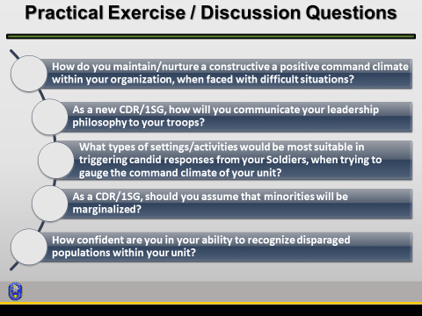

Facilitator notes: The questions in this PE will generate class discussion and will be an opportunity to review and incorporate leader attributes and competencies during this exercise. Before selecting questions for discussion, inform students of the objective and emphasize the need to reflect upon the core competencies and attributes that are universal for all Army leaders.

The core competency categories are—
- Leads: provides purpose, direction, and motivation; builds trust; provides an example; communicates.
- Develops: develops themselves, creates a positive climate, develops subordinates, and stewards the profession.
- Achieves: executes, adjusts, and gets results to accomplish tasks and missions on time and to standard.

The three categories of core attributes are—
- Character: the moral and ethical qualities of the leader.
- Presence: characteristics open to display by the leader and open to viewing by others.
- Intellect: the mental and social abilities the leader applies while leading.

Examples of questions to create class discussion:
- How do you maintain/nurture a constructive a positive command climate within your organization, when faced with difficult situations? Examples:
- UCMJ procedures
- Drug use
- Case of sexual assault
- Standing up for a soldier when the chain of command will not
- Extended period of isolation due to the pandemic

- As a new CDR/1SG, how will you communicate your command philosophy to your troops? Examples:
- Trust
- Award and punishment
- Communication
- Active listening
- Empathy

- What types of settings/activities would be most suitable in triggering candid responses from your Soldiers, when trying to gauge the command climate of your unit? Examples:
- Off-work environments
- DFAC
- Home visits
- One-on-one sensing sessions
- Incoming personal interviews

- As a new CDR/1SG, should you assume that minorities will be marginalized? Explain your reasoning.

- How confident are you in your ability to recognize disparaged populations within your unit? Examples:
- Stay in close contact with (chaplain, JAG, SARC/VA)
- Delegate - Allow your trusted senior leaders to be your eyes and ears
- Know the demographics of your unit
- Identify a senior mentor and get advice from peers
- Known thy self! When in doubt, seek professional development

Slide 14 – Practical Exercise / Discussion Questions – cont.
Facilitator actions: These are examples of questions to create class discussion. | 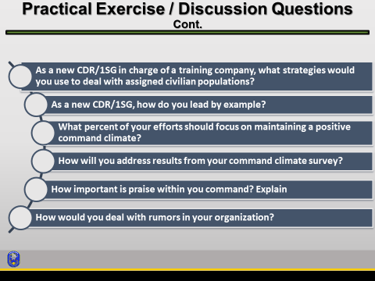

Facilitator notes: The questions in this PE will generate class discussion and will be an opportunity to review and incorporate leader attributes and competencies during this exercise. Before selecting questions for discussion, inform students of the objective and emphasize the need to reflect upon the core competencies and attributes that are universal for all Army leaders.

- As a new CDR/1SG, how do you lead by example?
Examples:
- Do not marginalize recurring training
- Be cognizant of locker room jokes
- Do not tolerate a toxic environment – Take action!
- Openly practice what you preach
- Identify destructive patterns early
- Take time to reflect on what you want to ask your troops
- Broadcast the idea that everyone is accountable

- What percent of your efforts should focus on maintaining a positive command climate?

- As a CDR/1SG in charge of a training company, what strategies would you use to deal with assigned civilian populations?

- How will you address results from your Organizational climate survey

- How important is praise within your command? Explain.
- Recognize efforts and excellence
- Tie efforts to a bigger purpose
- Sincerity in praise
- Do it publically and in private – consider your audience

- How would you deal with rumors in your organization?

Slide 15 - Company Commander and 1SG Relationship
Facilitator actions: This is one example of the unique relationship between the Co. CDR and the 1SG.  Based on what you just read, what are the responsibilities of the Company Commander?  What are the responsibilities of the 1SG? | 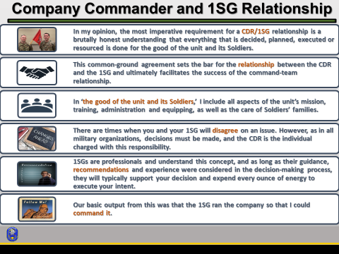

Facilitator notes: Refer to the chart below.

Company Commander | 1SG
Runs the “big picture” and deals with issues and personnel outside of the company | Deals with getting the CDR’s guidance out to the company and deals with Soldiers and personnel within the company
Sets overall policies and standards and are responsible for all the tasks and missions assigned to the company | Must provide the Soldiers the guidance, resources, assistance, and supervision necessary to perform their duties

Bottom line upfront (BLUF): This relationship is do or die. This relationship can make or break a unit. Soldiers will recognize the dysfunction or animosity in the command team. All of this rests on the CDR/1SG relationship. Many CDRs/1SGs say that their relationship is similar to that of couples with children. They joke that the Soldiers are their children, and if the command team doesn’t keep a united front, Soldiers will wear them down.

You can all probably remember commanders and 1SGs for which you appreciated their leadership. You trusted them because they considered their Soldiers’ needs; cared for their well-being; trained them to be mentally, physically, tactically and technically competent; and treated all Soldiers in the unit with fairness, justice, and equality.
The company commander and 1SG are a team. This relationship can make or break a unit and lead to either success or failure. Although you both will have different roles and responsibilities, it will be up to both of you to foster your relationship with each other for the benefit of your unit. This is a necessary and desirable outcome of close cooperation and should be a source of strength for a unit rather than a cause of friction. The commander’s role is one that encompasses management and guidance of the company. The 1SG’s role is one that encompasses advising the commander, overseeing training of the Soldiers, crews and teams, and enforcement of good order and discipline of Soldiers. First sergeants are known to maintain daily contact with and are responsible for training and ensuring the health and welfare of all of the unit’s soldiers and families. First sergeants hold formations, instruct platoon sergeants, and assist the commander in daily unit operations. Though first sergeants supervise routine administrative duties, their principle duty is training soldiers.

NOTE: Slides #16-22 are optional and are hidden. The slide notes provide additional information.

Transition and Develop: Finish the class by reminding students of the importance of establishing and maintaining a positive, ethical command climate. Present the supplemental materials/resources for additional learning that students can continue outside of class at their own pace.

Instructor Note: If you do not use any of the Back Up/Additional slides, move slide 21, Summary, to use here.

Slide 16 – Diversity – Equity - Inclusion
Facilitator actions: Army leaders are key enablers that drive organizational culture and climate and provide the resources, focus, venues, and authorities for full implementation of DEI across the total force.  Reference: Army People Strategy – Diversity, Equity, and Inclusion Annex dated 1 September 2020, page 5. | 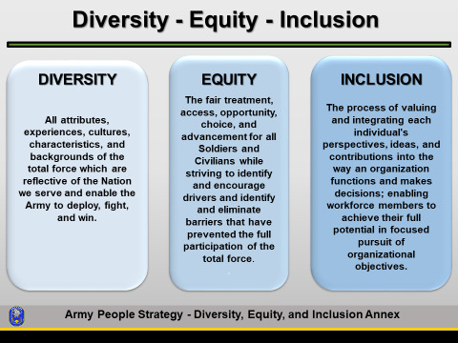

Facilitator notes: Query learners about DEI.

Why Diversity, Equity, and Inclusion?
The United States is one of the most diverse nations in the world and, in aggregate, the Army largely reflects the diversity of America. Projections of demographic shifts in the future indicate the nation and by default, the Army if it remains representative of the American population, will be even more diverse. As a commander or 1SG, you must consider DEI when assessing your climate. We have diversity, your job is to ensure we have equity and inclusion.

DEI is integral to building trust and achieving overall readiness and mission accomplishment of the total force. DEI enables organizational agility and adaptability by leveraging the attributes, experiences, cultures, characteristics, and backgrounds of the total force. DEI also ensures commanders and leaders are inclusive in their decisions, actions, and missions which enable access, opportunity, and choice for the total force.

Everyone in the Army is responsible for ensuring DEI. It is important to recognize that the Army’s commitment to DEI is an investment in mission accomplishment through the effective management of human capital, talent management, and personnel readiness. Leaders set priorities and establish policies that implement and sustain DEI practices at the individual, command, and organizational levels.

Slide 17 – Building and Maintaining a Positive Climate
This IMI can be used by all Army leaders to understand, assess, create, and sustain a positive command climate and increase unit effectiveness.  Note: The online lessons can be completed at any time. These IMIs are not required for the CCFSC, but they are available as an additional resource. You can bring up the site and start the IMI for a couple of minutes just to show students where it is and give them an idea of what they’ll get reviewing the IMI. | 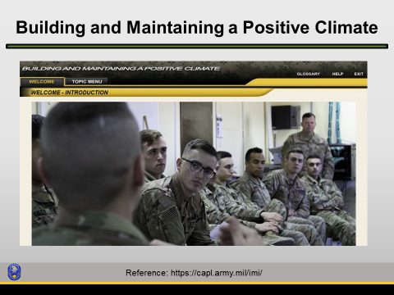

This online lesson/IMI ( https://capl.army.mil/imi/ ) discusses how Army leaders can leverage an action oriented approach to understand why climate matters and recognize what can be done to implement a positive command climate.

Slide 18 – Counterproductive Leadership
This IMI addresses issues that impact readiness, which is a priority for the Army and its senior leaders.  Counterproductive leadership (CPL) spans a range of leader conduct that can be organized into several broad categories that are useful to inform strategies for identifying and addressing such behaviors.  https://capl.army.mil/counterproductive-leadership/ | 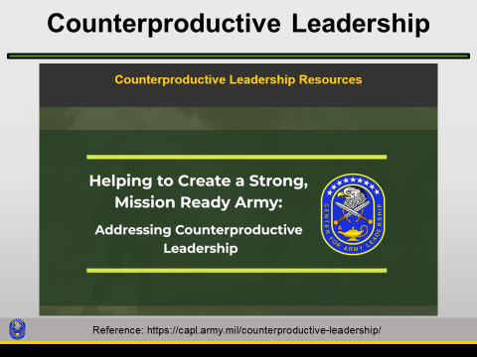

Facilitator notes: See the excerpts from ADP 6-22 below.
Counterproductive leadership spans a range of leader conduct that can be organized into several broad categories that are useful to inform strategies for identifying and addressing such behaviors. Counterproductive leadership is not limited to these behaviors listed below. Leaders can demonstrate more than one of the behaviors and their conduct can span multiple categories:
- Abusive behaviors—includes behaviors that involve a leader exceeding the boundaries of their authority by being abusive, cruel, or degrading others. These behaviors are contrary to what is required for the moral, ethical, and legal discharge of their duty. Specific examples include, but are not limited to, bullying, berating others for mistakes, creating conflict, ridiculing others because of the authority held, domineering, showing little or no respect to others, insulting or belittling individuals, condescending or talking down to others, or retaliating for perceived slights or disagreements.
- Self-serving behaviors—includes behaviors that result from self-centered motivations on the part of the leader, where they act in ways that seek primarily to accomplish their own goals and needs before those of others. Specific examples include, but are not limited to, displaying arrogance, lacking concern or empathy for others, taking credit for others' work, insisting on having their way, distorting information to favor own ideas, exaggerating accomplishments or abilities, putting own work and accomplishments ahead of others' and the mission, displaying narcissistic tendencies, or exhibiting a sense of entitlement.
- Erratic behaviors—includes behaviors related to poor self-control or volatility that drive the leader to act erratically or unpredictably. Specific examples include, but are not limited to, blaming others, deflecting responsibility, losing temper at the slightest provocation, behaving inconsistently in words and actions, insecurity, or being unapproachable.
- Leadership incompetence—includes ineffective leadership behaviors that result from a lack of experience or willful neglect. Incompetence can include failure to act or acting poorly. While incompetent leadership can arise from reasons unrelated to counterproductive leadership, it is included as a category often associated with arrogant or abusive leaders who are not aware of their shortcomings and do not seek to correct their shortcomings. Conversely, some leaders lacking competence are aware of their shortcomings, which lead them to behave in counterproductive or negative ways to cover up their shortcomings or mistakes. Specific examples include, but are not limited to, unengaged leadership, being passive or reactionary, neglecting leadership responsibilities, displaying poor judgment, poorly motivating others, withholding encouragement, failing to clearly communicate expectations, or refusing to listen to subordinates.
- Corrupt behaviors—includes behaviors that violate explicit Army standards, regulations, or policies. Violations may range from behaviors subject to administrative discipline to criminal actions subject to discharge or incarceration. Specific examples include, but are not limited to, dishonesty, misusing government resources or time, creating a hostile work environment, EEO/SHARP violations, or violating Section 3583 (Requirement of Exemplary Conduct), Title 10, United States Code, AR 600-100, or the Uniform Code of Military Justice.

Check on Learning
Question: Who is susceptible to CPL?
Answer: All leaders are susceptible to displaying counterproductive leadership behaviors in times of stress, high operational tempo, or other chaotic conditions to achieve short-term results (ADP 6-22 para 8-47).

Question: How does CPL affect the unit and mission?
Answer: Counterproductive leadership decreases followers' well-being, engagement, and undermines the organization's readiness and ability to accomplish the mission in the long term. It can have an adverse effect on the unit with cascading results, such as lowering morale, commitment, cohesion, effectiveness, readiness, and productivity (ADP 6-22 para 8-47).

Question: How does CPL relate to organizational climate?
Answer: Counterproductive leadership behaviors prevent establishing a positive organizational climate and interfere with mission accomplishment, especially in highly complex operational settings. Prolonged use of counterproductive leadership destroys unit morale, trust, and undermines the followers' commitment to the mission.
Counterproductive leadership can also decrease task performance, physical and psychological well-being, and increase negative outcomes such as depression or burnout (ADP 6-22 para 8-47).

Slide 19 – Unconscious or Implicit Biases
Facilitator actions: This is a back-up slide if students want to discuss bias in more detail.  The students have received previous instruction for EO, bias, diversity, equity, and inclusion (DEI) in earlier courses such as BOLC and CCC. | 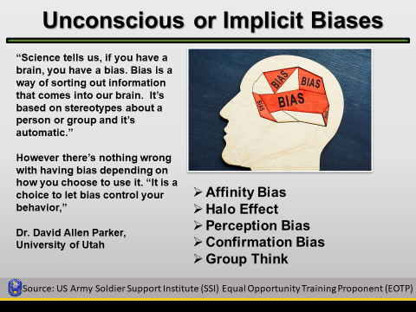

Facilitator notes: Review the description for bias below.

Bias – An unfair, illogical or unjustifiable judgment made in favor of or against a person, thing or group. [US Army Soldier Support Institute (SSI) EO Training Proponent (EOTP)]

Here are two additional definitions for bias.
- Bias a prejudice in favor of or against one thing, person, or group compared with another, usually in a way considered to be unfair. [Defense Equal Opportunity Management Institute (DEOMI)]
- Bias consists of attitudes, behaviors, and actions that are prejudiced in favor of or against one person or group compared to another. [National Institutes of Health (NIH) at https://diversity.nih.gov/sociocultural-factors/implicit-bias ]

Research shows that even before kindergarten, children already use their group membership (e.g., racial group, gender group, age group, etc.) to guide inferences about the psychological and behavioral traits. At such a young age, they have already begun to seek out patterns and recognize what distinguishes them from other groups (Baron, Dunham, Banaji, & Carey, 2014).
Be aware of your unconscious biases, and take steps to mitigate their effects. Also remember everyone in your formation will have biases and you will have to actively work to ensure these biases aren’t hindering equity and inclusion in your unit in order to develop and maintain a positive command climate

Unconscious biases, also known as implicit biases, are the underlying attitudes and stereotypes that people unconsciously attribute to another person or group of people that affect how they understand and engage with a person or group.

The term implicit bias was first coined back in 1995 by psychologists Mahzarin Banaji and Anthony Greenwald, where they argued that social behavior is largely influenced by unconscious associations and judgments (Greenwald & Banaji, 1995).

Specifically, implicit bias refers to attitudes or stereotypes that affect our understanding, actions, and decisions in an unconscious way, making them difficult to control. Since the mid-90s, psychologists have extensively researched implicit biases, revealing that, without even knowing it, we all possess our own implicit biases. A key reason we develop such biases is that our brains have a natural tendency to look for patterns and associations in order to make sense of a very complicated world.

Five common unconscious biases include the ones listed, but there are many more.
- Affinity bias, also known as similarity bias, is the tendency people have to connect with others who share similar interests, experiences and backgrounds. We tend to feel more comfortable around people who are like us.
- The Halo Effect is the tendency people have to place another person on a pedestal after learning something impressive about them. It’s a cognitive bias that occurs when an initial positive judgment about a person unconsciously colors the perception of the individual as a whole.
- Perception bias as the tendency to form stereotypes and assumptions about certain groups that makes it difficult to make an objective judgment about individual members of those groups. Meaning, if we have had the experience, that our neighbor's child, who is a Boy Scout, is a kind and generous child, who is always polite and helpful, when you meet another child who is also a Boy Scout, you might have a difficult time seeing any of his negative traits. It may involve other biases such as gender, age, and appearance.
- Confirmation bias is the inclination to draw conclusions about a situation or person based on your personal desires, beliefs and prejudices rather than on unbiased merit. It’s the tendency to process information by looking for, or interpreting, information that is consistent with one's existing beliefs. This biased approach to decision making is largely unintentional and often results in ignoring inconsistent information.
- Groupthink is a phenomenon that occurs when a group of well-intentioned people makes irrational or non-optimal decisions spurred by the urge to conform or the belief that dissent is impossible.

Slide 20 - Summary
Facilitator actions: Summarize key topics of LP and identify any questions.  Instructors may use the check on learning questions to summarize key points. | 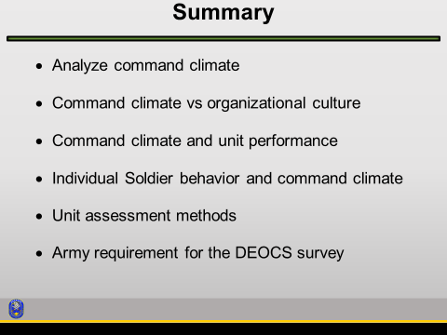

Check on Learning

Question: What are some reasons leaders want to assess the cohesiveness of their units?
Expected response: It gives the leader indications of what they either need to improve or sustain (ref: Building and Maintaining a Positive Climate Handbook).

Question: Is it recommended that you ask for feedback from your Soldiers and subordinates?
Expected response: It is not only recommended, but it is required (ref: AR 600-20).

Question: What is the timeline to do a command climate survey?
Expected response: Within 30 days of taking command, six months after this, and annually thereafter (ref: AR 600-20).

Question: What are some indicators of a healthy command climate?
Expected response:
- A willingness to report violations, sexual harassment, unequal treatment, etc… to the chain of command.
- Productivity increases.
- Trust is prevalent.
- Troops display self-confidence.
- Cohesiveness and morale are high.
Note: See fig. 5, p. 10 – Outcomes (ref: Building and Maintaining a Positive Climate Handbook)

Today's military climate demands CDRs/1SGs who foster positive command climates. The better the command climate, the better your Solders will be, and in turn the better leader you will be. Positive command climate comes into all aspects of your operations, in the field or in garrison.

You have the duty, obligation, and privilege of setting the standard for your Soldiers. You will set the example for all in your unit to follow because you are a member of a generation of leaders called to greatness. Your command climate will make or break many situations that you may find yourself and your Soldiers in and will allow you lead them in the best way possible. You may have to deal with everything from reenlistments, birth of children, and death of spouses or military members.

You will have to consider all aspects of: what you say, how you say it, any actions you might take, and the repercussions of all of these. Fostering a positive climate now will allow your unit to achieve positive results. When you set the example, your Soldiers will want to follow. By using these skills, you teach the next generation of Soldiers valuable leadership skills.

Slide 21 - CAPL Training and Education Resources
Facilitator actions: Refer students to the CAPL Training and Education Resources.  Encourage participants to visit the website on their own time to explore the resources there. Mention video case studies as a training tool they can use. | 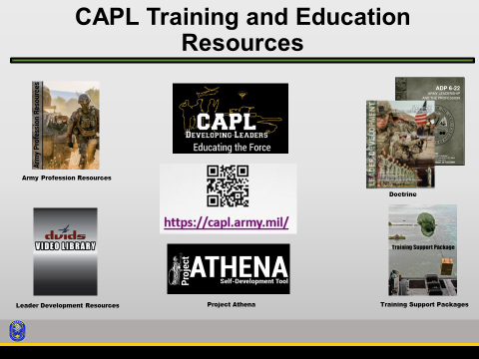

Facilitator notes: We want to highlight the vast resources that the Center for the Army Profession and Leadership (CAPL) provides the Army. CAPL is the proponent for the Army Profession, leadership, and leader development. CAPL’s vision is to strengthen America's Army as a military profession that inspires trusted Army professionals to honorably fulfill their oaths of service. We do this by providing Army profession, leadership and leader development studies, doctrine, products and services and by integrating personnel lifecycle functions in order to reinforce the Army profession and enhance leader and unit performance at all echelons.

- ASSESSMENT PLAN: The facilitator will evaluate the learner's ability to analyze the key concepts through participation in class discussions. The instructors will ensure that students participate in and complete all learning step activities (LSAs).

- ENVIRONMENTAL IMPACT STATEMENT: See data in TDC.

- RISK ASSESSMENT/RISK CONTROL MEASURES: See data in TDC.

