

Drills/Positions Performance Measures

Rifle and Carbine

Student Name:____________________________________________________

Roster Number:___________________________________________________

**Drill A-Weapon Check**

**Performance Measures:**

1. Receive the weapon and attachments.

2. Clear the weapon.

a. place the weapon in your workspace

b. Point the muzzle in a safe direction.

c. Place the weapon on SAFE.

**Note: If the weapon is not cocked, you cannot place the selector lever on SAFE.**

d. Lock the bolt open.

i. Pull the charging handle to the rear

ii. Press the bottom portion of the bolt catch

iii. Allow the bolt to move forward until it engages the bolt catch

iv. Return the charging handle to the full forward position

v. Place the selector lever on SAFE.

**Note: If the weapon was cocked before locking the bolt open then the selector lever should already be on SAFE.**

e. Ensure that no ammunition is in chamber, the magazine well, or on the bolt face.

f. Return the bolt to the closed position.

i. Press the upper portion of the bolt catch allowing the bolt to go forward.

ii. Close the ejection port cover.

3. Verify weapon serial number.

4. Verify attachments serial numbers (if applicable).

5. Inspect attachment points and proper location of all aiming device, serviceability of equipment, and accessories (if applicable).

a. Ensure attachments are secured properly

b. Ensure location of attachments are according to unit SOP and do not interfere with operation of the weapon.

c. Ensure all attachments are serviceable, have fresh batteries, and operate properly IAW respective equipment TM.

6. Conduct a functions check of the weapon.

a. Place selector lever on SAFE.

b. Pull charging handle to rear and release.

c. Squeeze the trigger.

**Note: Hammer should not fall.**

d. Place selector lever on SEMI.

e. Squeeze the trigger.

**Note: Hammer should fall.**

f. Hold the trigger to the rear and charge the weapon.

g. Release the trigger smoothly and evenly until the trigger is fully forward.

**Note: A metallic click should be heard.**

h. Squeeze the trigger.

**(M16A3 and M4A1 only)**

**Note: Hammer should fall.**

p. Place the selector switch on AUTO

q. Pull the charging handle to the rear, charging the weapon.

r. Squeeze the trigger.

**Note: Hammer should fall**.

s. Hold the trigger to the rear.

t. Charge the weapon again.

u. Fully release the trigger then squeeze it again.

**Note: The hammer should not fall because it should have fallen when the bolt was allowed to move forward during the chambering and locking sequences.**

**(M16A2, M16A4, and M4 only)**

**Note: Hammer should fall.**

i. Place the selector lever on BURST

j. Charge the weapon one time.

k. Squeeze the trigger.

**Note: Hammer should fall.**

l. Hold the trigger to the rear.

m. Charge the weapon three times.

n. Release the trigger.

o. Squeeze the trigger.

7. Inspect serviceability of all magazines and stow them in load carrying equipment.

a. Inspect all magazine shells and followers IAW TM 9-1005-319-10, Chapter 4

b. Ensure all magazines fit easily into magazine well of weapon and lock in place securely.

c. Place magazines in magazine pouches and ensure they are secured properly IAW unit SOP.

8. Place the weapon on safe

**Drill B- Sling/Unsling**

**Performance Measures**

1. Maintain muzzle awareness.

2. Sling the weapon.

a. Point the muzzle in a safe direction.

b. While holding the weapon at the low ready, grasp sling with non-firing hand.

c. Move sling up and over the helmet and non-firing shoulder, allowing the sling to hang below the non-firing arm and release the sling.

d. Grasp the rifle forward grip with non-firing hand.

3. Adjust the sling.

a. Maintain grasp of the weapon with the firing hand.

b. Move non-firing hand to sling adjustment point.

c. Adjust the sling to an appropriate distance to allow Soldier to rotate torso left and right. Ensure the sling or weapon do not hang up on any equipment.

d. Ensure Soldier can maintain effective use of the weapon through all positions (prone, kneeling, and standing).

e. Release sling adjustment point and return non-firing hand to forward grip of weapon.

4. Orient the weapon on an assigned target and move between firing positions.

a. From the standing position, raise the weapon to the READY UP position and aim at an assigned target.

b. Move to the kneeling position, maintaining weapon orientation toward target, and ensure weapon and equipment do not interfere with tactical movement.

c. Move to the sitting position, maintaining weapon orientation toward target, and ensure weapon and equipment do not interfere with tactical movement.

d. Move to the prone position, maintaining weapon orientation toward target, and ensure weapon and equipment do not interfere with tactical movement.

**Drill C-Equipment Check**

**Performance Measures**

**NOTE: This drill is a Pre-Combat Check (PCC) that ensures the Soldier’s aiming devices, equipment and accessories are prepared. Drill C is completed at the conclusion of performing Drills A and B.**

-Batteries

- Secured Correctly

- Equipment does not interfere with tactical movement

- Basic load of magazines are stowed properly

**Drill D- Load**

**Performance Measures**

1. Move the weapon into workspace ensure muzzle awareness, weapon is pointed in a safe direction and place the weapon on safe.

a. Ensure firing finger is straight and off the trigger, pressed alongside the lower receiver.

b. Rotate the weapon into workspace.

2. Lock the bolt to the rear.

a. Pull the charging handle rearward.

b. Press and hold the bottom of the bolt catch.

c. Allow the bolt to move forward until it engages the bolt catch.

d. Release the bottom of the bolt catch.

e. Return the charging handle to the forward position.

3. Ensure the weapon is clear.

a. Check the chamber, bolt face, and magazine well to ensure they are clear.

4. Insert the magazine.

a. With your index finger determine which side of the magazine feed lips the round is on. (This will be used to ensure the weapon is loaded)

b. Push the magazine upwards in the magazine well until the magazine catch engages.

c. Pull down on the magazine to ensure the magazine is properly seated.

**NOTE: Do not slap upward to seat the magazine. This action is one of the primary causes of a double feed. This action can even induce a malfunction with a serviceable magazine.**

5. Chamber a round.

**NOTE: The bolt should not be rode forward.**

a. Press the upper portion of the bolt catch allowing the bolt to go forward

6. MAG CHECK

a. Remove the magazine and with your index finger inspect to ensure that the round is on the opposite side of the magazine feed lips. This indicates a round has been loaded.

b. Re-insert the magazine pushing until it locks in place, signified by hearing the magazine release click. Pull downward on the magazine to ensure it is locked.

c. Close the ejection port cover.

Or

7. Press check

**NOTE: This check can be conducted in place of the magazine round check, during low light the mag check should be used**

a. place the thumb of your non-firing hand in line with the castle nut, with the index finger on the left side of the charging handle.

b. pull the charging handle back to the thumb

c. simultaneously rotate the weapon so that the ejection port is visible.

d. visually inspect that a round is in the chamber.

e. release the charging handle

f. Press the forward assist with the non-firing hand

g. Close the ejection port cover.

.

**Drill E- Carry**

**Performance Measures**

1. Maintain muzzle awareness through all carry positions.

2. Ensure the weapon is on Safe.

3. Demonstrate Hang carry position. On the command **“Assume Hang”:**

a. Ensure the selector lever is on safe and sling the weapon.

b. Ensure the weapon is slung from the firing shoulder across the chest toward the non-firing hand.

c. Hands are to the sides.

4. Move to and demonstrate the Safe Hang carry position. On the command **“Assume Safe Hang”**:

a. Ensure weapon remains slung across Soldiers chest.

b. With the firing hand grasp the pistol grip of the weapon while keeping the finger off the trigger.

c. Non-firing hand does not move.

5. Move to and demonstrate the Collapsed Low Ready carry position. On the command **“Assume Collapsed”**:

a. Ensure weapon remains slung across the Soldiers chest.

b. Ensure firing hand remains on pistol grip with finger off trigger.

c. With non-firing hand grasp the hand guards or vertical fore-grip of the weapon.

6. Move to and demonstrate the Low Ready carry position. On the command **“Go Low Ready”**:

a. Ensure weapon remains on safe.

b. With weapon slung across chest, assume an aggressive posture (non-firing foot approximately 15 inches forward of firing foot, knees slightly bent, hips level and squared up toward engagement area, torso slightly leaning forward, head and eyes level on engagement area).

c. With the firing hand grasp the pistol grip keeping finger off the trigger. Grasp the hand guard or fore-grip with the non-firing hand and raise the buttstock of the weapon to the firing pocket of the shoulder.

d. Raise the muzzle of the weapon until it is roughly at a downward angle of 30-45 degrees below the field of view.

e. Ensure positive control of weapons pistol grip is maintained and finger remains off trigger.

7. Move to and demonstrate the High Ready carry position. On the command **“Go High Ready”:**

a. Ensure the weapon remains on safe.

b. With weapon slung across chest, assume an aggressive posture (non-firing foot approximately 15 inches forward of firing foot, knees slightly bent, hips level and squared up toward engagement area, torso slightly leaning forward, head and eyes level on engagement area).

c. With the firing hand grasp the pistol grip keeping finger off the trigger. Grasp the hand guard or fore-grip with the non-firing hand and move the buttstock of the weapon under the firing side armpit.

d. Raise the muzzle of the weapon until it is roughly at an upward angle of 45 degrees above the field of view and oriented into the engagement area.

e. Ensure positive control of weapons pistol grip is maintained and finger remains off trigger.

8. Move to and demonstrate the Ready or Ready-Up carry position. On the command **“Ready Up”:**

a. Ensure the weapon remains on safe.

b. With weapon slung across chest, assume an aggressive posture (non-firing foot approximately 15 inches forward of firing foot, knees slightly bent, hips level and squared up toward engagement area, torso slightly leaning forward, head and eyes level on engagement area).

c. With the firing hand grasp the pistol grip keeping finger off the trigger. Grasp the hand guard or fore-grip with the non-firing hand and raise the buttstock of the weapon until the toe of the buttstock is in the firing pocket of the shoulder.

d. Raise the muzzle of the weapon until it is oriented toward a threat or most likely direction of enemy contact.

e. Ensure Soldier is looking through sights or optics.

f. Ensure positive control of weapons pistol grip is maintained and finger remains off trigger.

**Drill F- Fight Down**

**Performance Measures**

1**.** This Drill starts in a standing firing position and the Soldier will maintain muzzle awareness through all positions

2. On the command of **“FIGHT DOWN”** from the standing firing position, the Soldier:

a. Rapidly acquire the assigned target.

b. Drop from the standing firing position to the kneeling firing position.

i. Achieve a stable position.

ii. Reacquire the assigned target.

3. On the command of **“FIGHT DOWN”** from the kneeling firing position, the Soldier:

a. Rapidly acquire the assigned target.

b. Drop from the kneeling firing position to the sitting firing position.

i. Achieve a stable firing position.

ii. Reacquire the assigned target.

4. On the command of **“FIGHT DOWN”** from the sitting firing position, the Soldier:

a. Rapidly acquire the assigned target.

b. Drop from the sitting firing position to the prone firing position.

i. Achieve a stable firing position.

ii. Reacquire the assigned target.

**Drill G- Fight Up**

**Performance Measures**

1**.** This Drill starts in a prone firing position and the Soldier will maintain muzzle awareness through all positions

2. On the command of **“FIGHT UP”** from the prone firing position, the Soldier:

a. Rapidly acquire the assigned target.

b. Moves from the prone firing position to the sitting firing position.

i. Achieve a stable position.

ii. Reacquire the assigned target.

3. On the command of **“FIGHT UP”** from the sitting firing position, the Soldier:

a. Rapidly acquire the assigned target.

b. Moves from the sitting firing position to the kneeling firing position.

i. Achieve a stable firing position.

ii. Reacquire the assigned target.

4. On the command of **“FIGHT UP”** from the kneeling firing position, the Soldier:

a. Rapidly acquire the assigned target.

b. Moves from the kneeling firing position to the standing firing position.

i. Achieve a stable firing position.

ii. Reacquire the assigned target.

**Drill H- Go-To-Prone**

**Performance Measures**

1. Shooter must maintain muzzle awareness

2. On the command of **“GO TO PRONE”,** the Soldier:

a. Rapidly acquire the assigned target.

b. Point, Post, Sprawl.

i. Point - Point the rifle down range towards the target.

ii. Post -- Post your non-firing hand on the ground naturally in front of you.

iii. Sprawl – Kick your legs rearward and out so that your body lays naturally on the ground in good firing position.

c. Reacquire the assigned target.

**Drill I- Reload**

**Performance Measures**

**NOTE: Maintain situational and muzzle awareness through all movement and firing positions.**

**1. Conduct reload without retention of magazine.**

**NOTE: Conduct this drill from the standing, kneeling, sitting, and prone firing positions.**

a. Bolt is locked to the rear with an empty magazine in the weapon.

b. Maintain focus toward threat or engagement area.

c. Remove finger from the trigger and press it alongside the lower receiver.

d. Place the weapon on Safe.

e. Depress the magazine release button while the weapon is still horizontal to allow the magazine to fall to the ground.

f. Begin to lower the weapon and trap the buttstock underneath the firing arm.

g. Bring the rifle into workspace and ensure the magazine well is rotated toward the non-firing side. Simultaneously, retrieve a magazine from load carrying equipment with non-firing hand.

h. Shift focus toward magazine well and guide new magazine into magazine well. Shift focus back toward threat or engagement area.

i. Seat the magazine by pushing upward into the magazine well until the magazine catch engages. Ensure it is seated by pulling downward on the magazine.

j. Depress the bolt release with the non-firing hand and present the rifle to the next threat or engagement area.

**2. Conduct reload with retention of magazine.**

**NOTE: Conduct this drill from the standing, kneeling, sitting, and prone firing positions.**

a. Bolt is locked forward with a partial magazine in the weapon.

b. Maintain focus toward threat or engagement area.

c. Remove finger from the trigger and press it alongside the lower receiver.

d. Place the weapon on Safe.

e. Bring the rifle into workspace and ensure the magazine well is rotated toward the non-firing side. Simultaneously, retrieve a magazine from load carrying equipment with non-firing hand. Ensure the magazine is secured in a grip that will allow a magazine change with one hand.( L-shape or side by side)

f. While holding both magazines in non-firing hand, depress magazine release and remove the partial magazine from the magazine well and replace it with the new magazine.

g. Push upward with the new magazine to ensure the magazine catch engages. Pull downward to ensure it has seated properly.

h. Stow the partial magazine in a magazine pouch, dump pouch, or cargo pocket. (1 attempt)

i. Return non-firing hand to the weapon and present it to the next threat or into the engagement area.

**Drill J- Clear Malfunction**

**Performance Measures**

**1. Perform immediate action only when the bolt is forward and the hammer has fallen.**

**NOTE: Maintain muzzle awareness.**

a. Hammer falls with an audible “click.”

b. Tap the bottom of the magazine.

c. Rapidly pull the charging handle and release to extract / eject the previous cartridge and feed, chamber, and lock a new round.

d. Reassess by continuing the shot process.

**DANGER: If weapon stops firing with a live round in the chamber of a hot barrel, remove the round quickly. However, if you cannot remove it within 10 seconds, remove magazine and wait 15 minutes with the weapon pointed in a safe direction. This will avoid injury during possible cook-off. Always keep face away from the ejection port when clearing a hot chamber. **In a Training environment only\*\***

**2. Perform remedial action.**

***Note:* Occurs when weapon is out of battery (mushy trigger), or tap, rack fails**

***Note:* Maintain safe muzzle awareness.**

a. Seek cover and move weapon into workspace.

b.. Correct an obstructed chamber.

i. Attempt to place the weapon on SAFE.

ii. Forcefully remove the magazine.

iii. Lock the bolt to the rear and return the charging handle forward.

iv. Place the selector lever on SAFE, if not already done.

v. Clear obstruction and visually inspect the chamber, bolt face, and magazine well.

vii. Insert new magazine

**DANGER: DO NOT attempt to remove a round stuck in the barrel of a weapon; turn the weapon in to field maintenance.**

**Drill K- Unload/Show Clear**

**Performance Measures**

1. Ensure muzzle awareness, and place the selector lever on Safe and move the weapon into workspace

2. Remove the magazine.

a. Depress the magazine catch button.

b. Pull down on the magazine to remove.

3. Lock the bolt to the rear.

a. Pull the charging handle rearward.

b. Press and hold the bottom of the bolt catch.

c. Allow the bolt to move forward until it engages the bolt catch.

d. Release the bottom of the bolt catch.

e. Return the charging handle to the forward position.

4. Ensure that no ammunition is in the chamber, the magazine well, or on the bolt face.

5. Have teammate conduct a three-point safety check.

6. Return the bolt to the closed and forward position.

a. Press the upper portion of the bolt catch allowing the bolt to go forward.

b. Close the ejection port cover.

**CARRY POSITIONS**

**HANG**

6-13. Soldiers use the hang when they need their hands for other tasks and no threat is

present or likely (see figure 6-2). The weapon is slung and the safety is engaged. The

hang carry should not be used when the weapon control status is RED. The reduced

security of the weapon may cause the mechanical safety select lever to unintentionally

move to SEMI or BURST/AUTO.

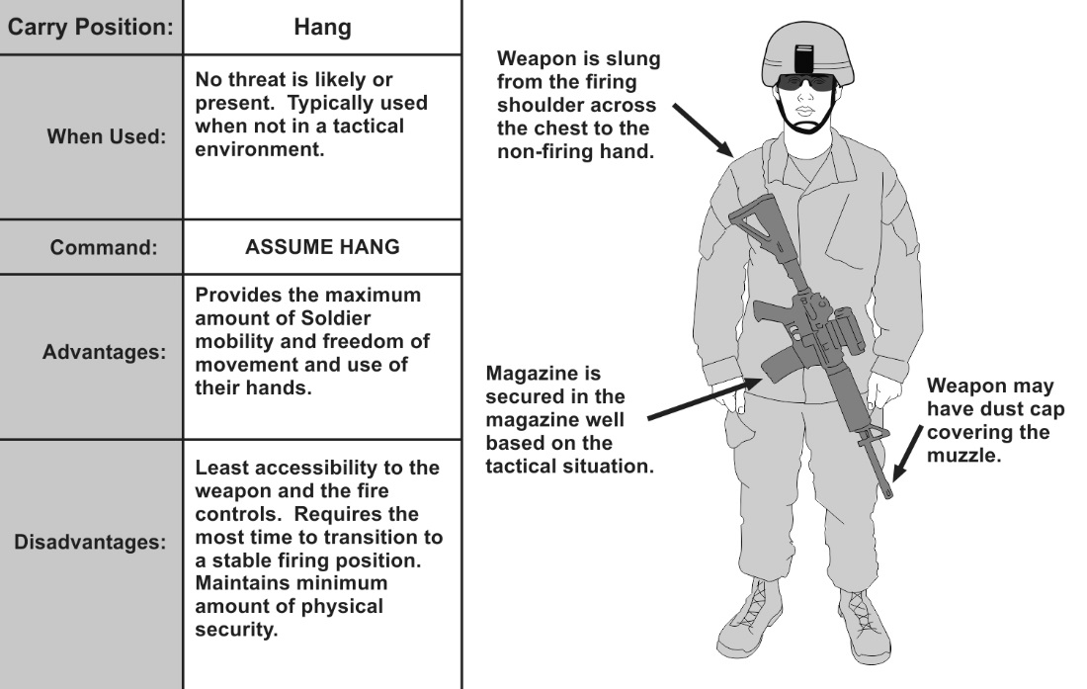

**Figure 6-2. Hang carry example**

**SAFE HANG**

6-14. The safe hang is used when no immediate threat is present and the hands are not

necessary (see figure 6-3). In the safe hang carry, the weapon is slung, the safety is

engaged, and the Soldier has gripped the rifle’s pistol grip. The Soldier sustains Rule 3,

keeping the finger off the trigger until ready to engage when transitioning to the ready

or ready up position.

6-15. In this position, the Soldier can move in any direction while simultaneously

maintaining his muzzle oriented at the ground by using his firing hand. This carry

provides control of the weapon, flexibility in movement, and positive control of the

weapon’s fire controls.

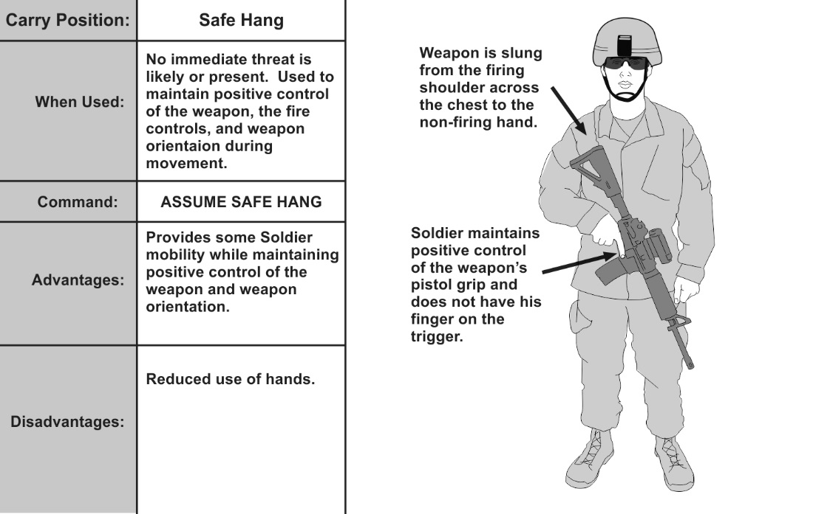

**Figure 6-3. Safe hang example**

**COLLAPSED LOW READY**

6-16. The collapsed low ready is used when a greater degree of muzzle control and

readiness to respond to threats or weapon retention is necessary (such as crowded

environments). In the collapsed low ready, the firing hand is secure on the weapon’s

pistol grip. The non-firing hand is placed on the hand guards or vertical fore-grip (see

figure 6-4).

6-17. This carry allows a Soldier to navigate crowded or restrictive environments while

simultaneously minimizing or eliminating his muzzle covering (flagging) by

maintaining positive control of the muzzle orientation.

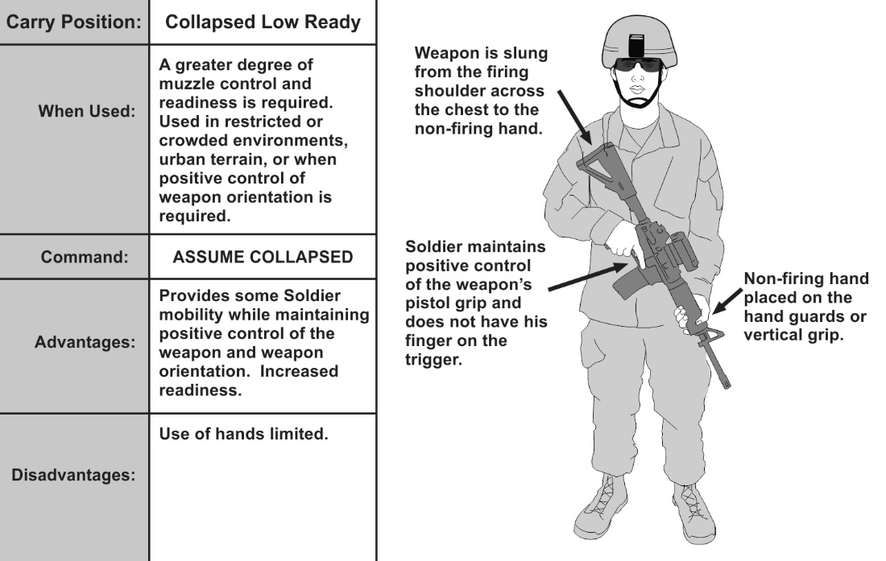

**Figure 6-4. Collapsed low ready example**

**LOW READY**

6-18. The low ready provides the highest level of readiness and with the maximum

amount of observable area for target acquisition purposes

6-19. In the low ready position, the weapon is slung, the butt stock is in the Soldier’s

shoulder, and the muzzle is angled down at a 30- to 45-degree angle and oriented

towards the Soldier’s sector of fire.

6-20. Firing hand is positioned on the pistol grip with the index finger straight and out

of the trigger guard. The thumb is placed on the selector lever with the lever placed on

safe. From this carry, the Soldier is ready to engage threats within a very short amount

of time with minimal movement. (See figure 6-5).

6-21. Observation is maintained to the sector of fire. The Soldier looks over the top of

his optics or sights to maintain situation awareness of his sector. The Soldier’s head

remains upright.

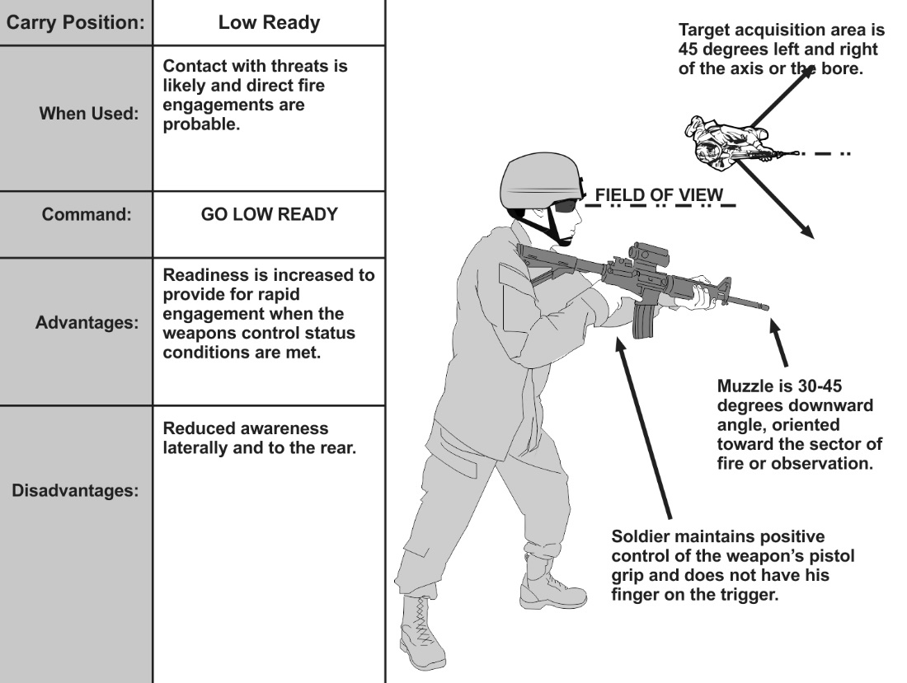

**Figure 6-5. Low ready position**

**HIGH READY**

6-22. The high ready is used when the Soldier’s sector of fire includes areas overhead or

when an elevated muzzle orientation is appropriate for safety (see figure 6-6). The high

ready carry is used when contact is likely.

6-23. In the high ready, the weapon is slung, butt stock is in the armpit, the muzzle

angled up to at least a 45-degree angle and oriented toward the Soldier’s sector of fire—

ensuring no other Soldiers are flagged.

6-24. The firing hand remains in the same position as the low ready. The non-firing

side hand can be free as the weapon is supported by the firing side hand and armpit.

6-25. This position is not as effective as the low ready for several reasons: it impedes

the field of view, flags friendlies above the sector of fire, and typically takes longer to

acquire the target.

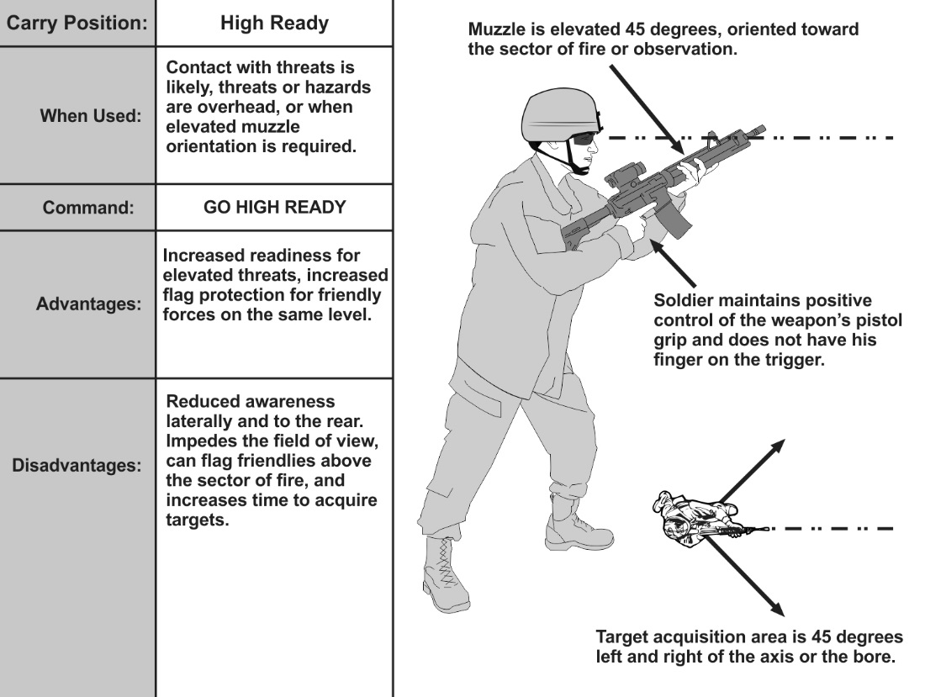

**Figure 6-6. High ready position**

**READY OR READY-UP**

6-26. The ready is used when enemy contact is imminent (see figure 6-7). This carry is

used when the Soldier is preparing or prepared to engage a threat.

6-27. In the ready, the weapon is slung, the toe of the butt stock is in the Soldier’s

shoulder, and muzzle is oriented toward a threat or most likely direction of enemy

contact. The Soldier is looking through his optics or sights. His non-firing side hand

remains on the hand guards or the vertical fore-grip.

6-28. The firing hand remains on the pistol grip with the firing finger off the trigger

until the decision to engage a target is made.

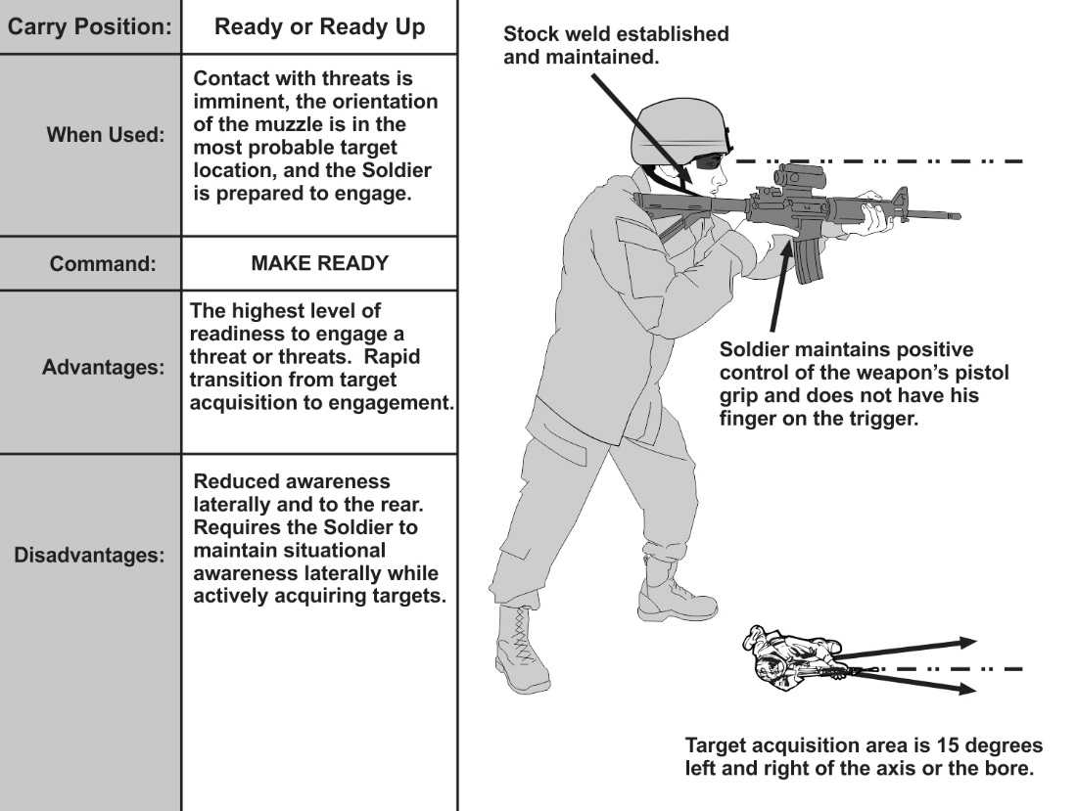

**Figure 6-7. Ready position or up position**

**FIRING POSITIONS**

**STANDING, UNSUPPORTED**

6-37. This position should be used for closer targets or when time is not available to

assume a steadier position such as short range employment. The upper body should be

leaned slightly forward to aid in recoil management. The key focus areas for the standing

supported position are applied as described in figure 6-9 below:

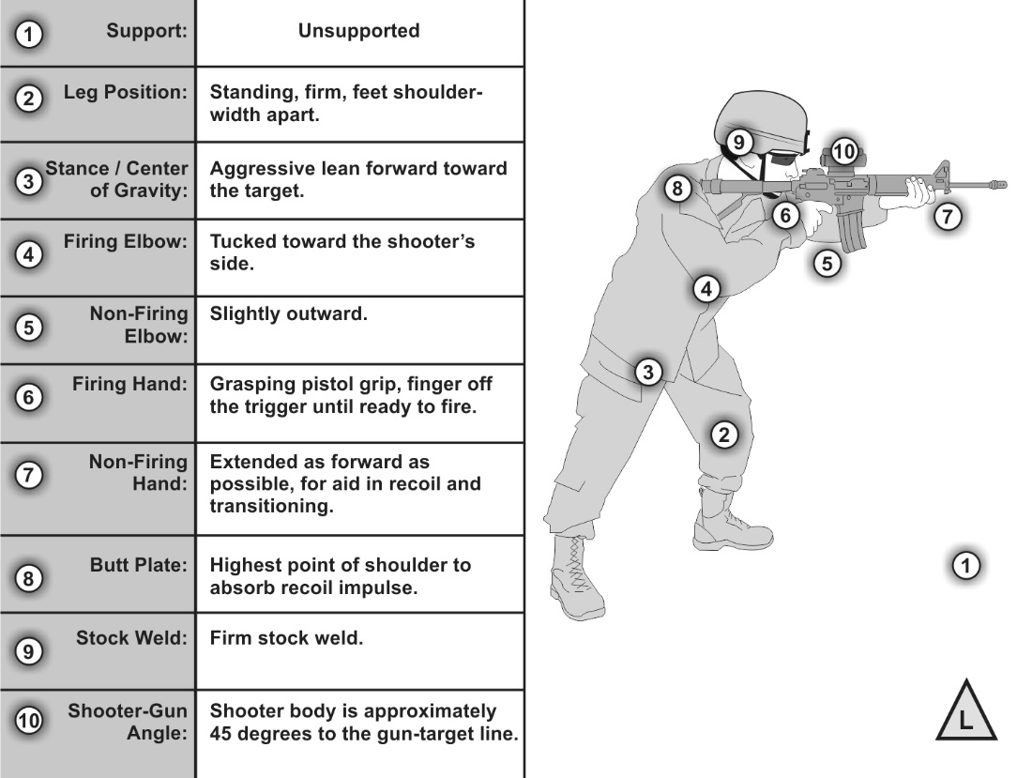

**Figure 6-9. Standing, unsupported example**

**STANDING, SUPPORTED**

6-38. Soldier should ensure it is the handguard of the weapon NOT the barrel that is in

contact with the artificial support. Barrels being in direct contact with artificial support

will result in erratic shots. The standing supported position uses artificial support to

steady the position (see figure 6-10.) Forward pressure should be applied by the rear leg

and upper body to aid in recoil management. The key focus area for the standing

supported position are applied in the following ways:

**Non-firing hand.** The non-firing hand will hold the hand guards firmly and push

against the artificial support. Hand positioning will vary depending on the type

of support used.

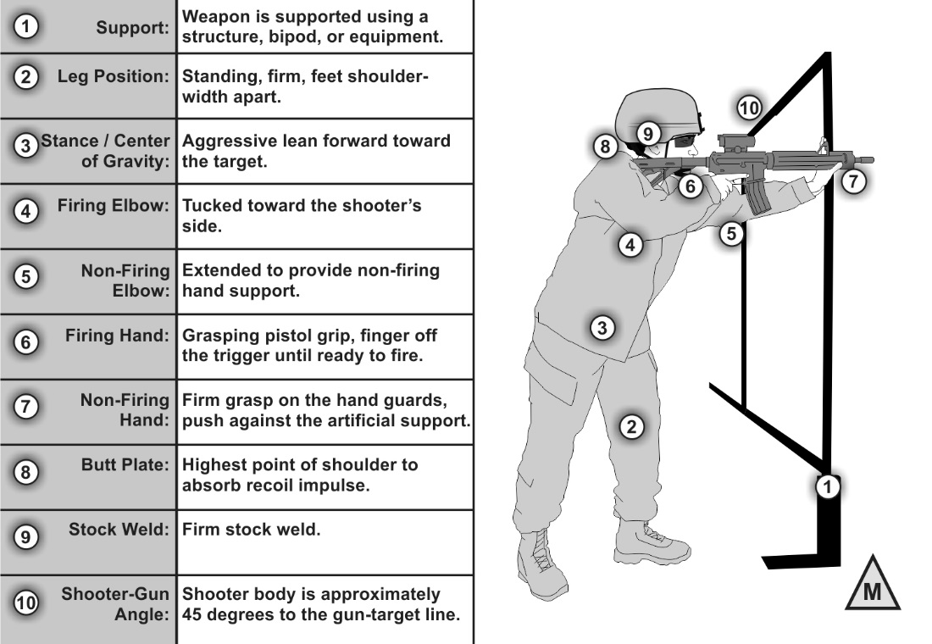

**Figure 6-10. Standing, supported example**

**SQUATTING**

6-39. This position allows for rapid engagement of targets when an obstruction blocks

the firer from using standard positions. It allows the firer a fairly stable position by

simply squatting down to engage, then returning to a standing position after completing

the engagement (see figure 6-11.)

6-40. Perform the following to assume a good squatting firing position:

-Face the target.

-Place the feet shoulder-width apart.

-Squat down as far as possible.

-Place the back of triceps on the knees ensuring there is no bone on bone contact.

-Place the firing hand on the pistol grip and the non-firing hand on the upper hand guards.

-Place the weapon's butt stock high in the firer’s shoulder pocket.

**Note. The firer may opt to use pressure from firing hand to rotate weapon to**

**place the magazine against the opposite forearm to aid in stabilization.**

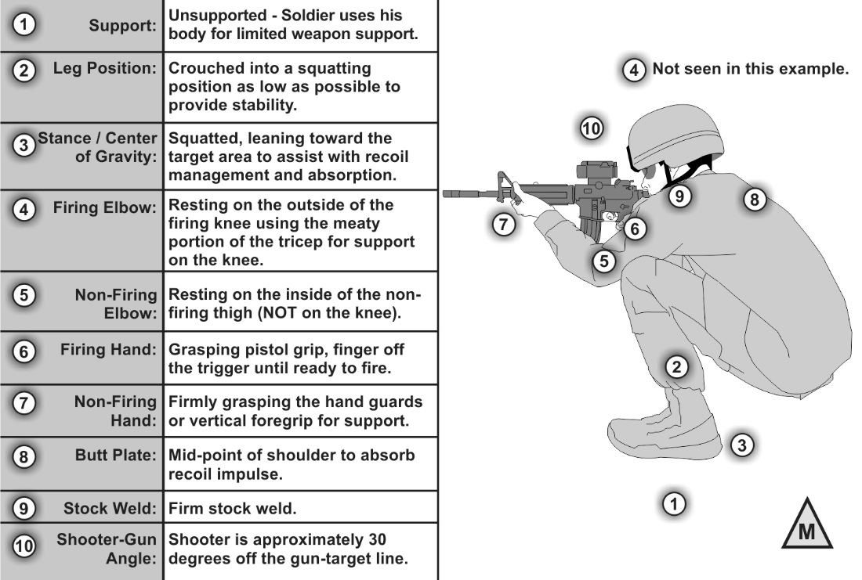

**Figure 6-11. Squatting position**

**KNEELING, UNSUPPORTED**

6-41. The kneeling unsupported position does not use artificial support. Figure 6-12

shows the optimum unsupported kneeling position. The firer should be leaning slightly

forward into the position to allow for recoil management and quicker follow-up shots.

The primary goal of this firing position is to establish the smallest wobble area possible.

Key focus areas for kneeling, unsupported are:

**-Non-firing elbow.** Place the non-firing elbow directly underneath the rifle as much as possible. The elbow should be placed either in front of or behind the kneecap. Placing the elbow directly on the kneecap will cause it to roll and increases the wobble area.

**-Leg position.** The non-firing leg should be bent approximately 90 degrees at the knee and be directly under the rifle. The firing-side leg should be perpendicular to the non-firing leg. The firer may rest their body weight on the heel. Some firers lack the flexibility to do this and may have a gap between their buttocks and the heel.

**-Aggressive (stretch) kneeling.** All weight on non-firing foot, thigh to calf, upper body leaning forward, non-firing triceps on non-firing knee, firing leg stretched behind for support. Highly effective for rapid fire and movement.

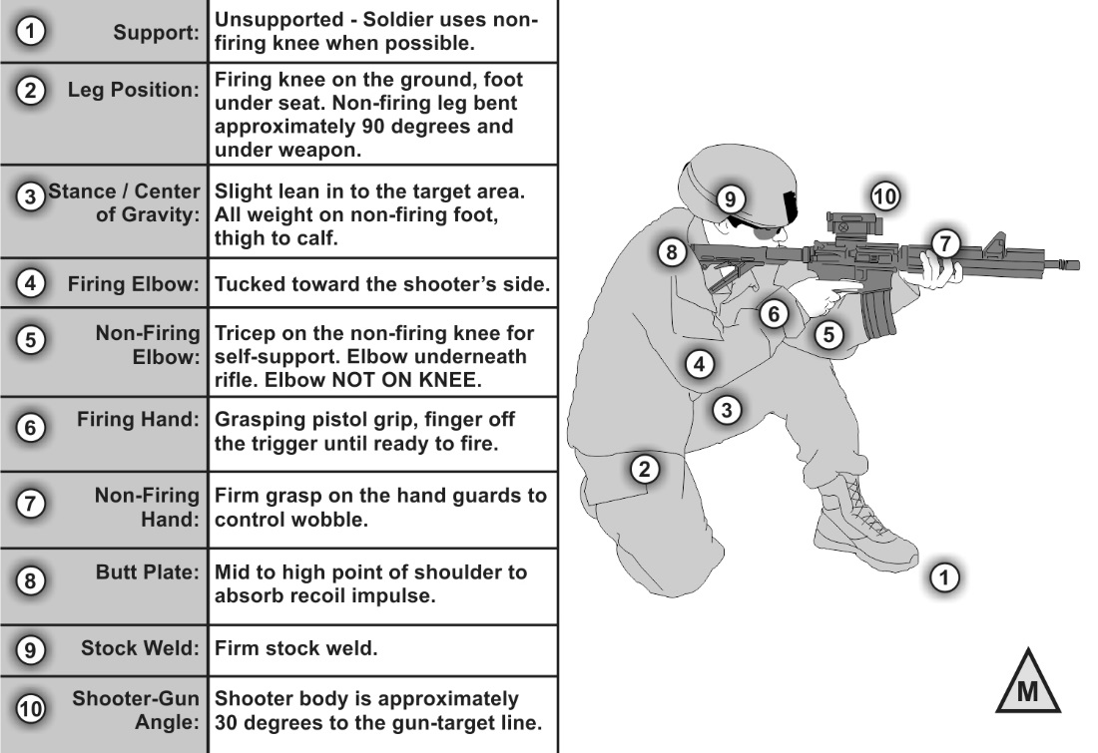

**Figure 6-12. Kneeling, unsupported example**

**KNEELING, SUPPORTED**

6-42. The kneeling supported position uses artificial support to steady the position (see

figure 6-13). Contact by the non-firing hand and elbow with the artificial support is the

primary difference between the kneeling supported and unsupported positions since it

assists in the stability of the weapon. Body contact is good, but the barrel of the rifle

must not touch the artificial support. Forward pressure is applied to aid in recoil

management. The key focus areas for the kneeling supported position are applied in the

following ways:

**-Non-firing hand.** The non-firing hand will hold the hand guards firmly and will also be pushed against the artificial support. Hand positioning will vary depending on the type of support used.

**-Non-firing elbow.** The non-firing elbow and forearm may be used to assist with the weapon’s stability by pushing against the artificial support. The contact of the non-firing elbow and forearm with the structure will vary depending on the support used and the angle to the target.

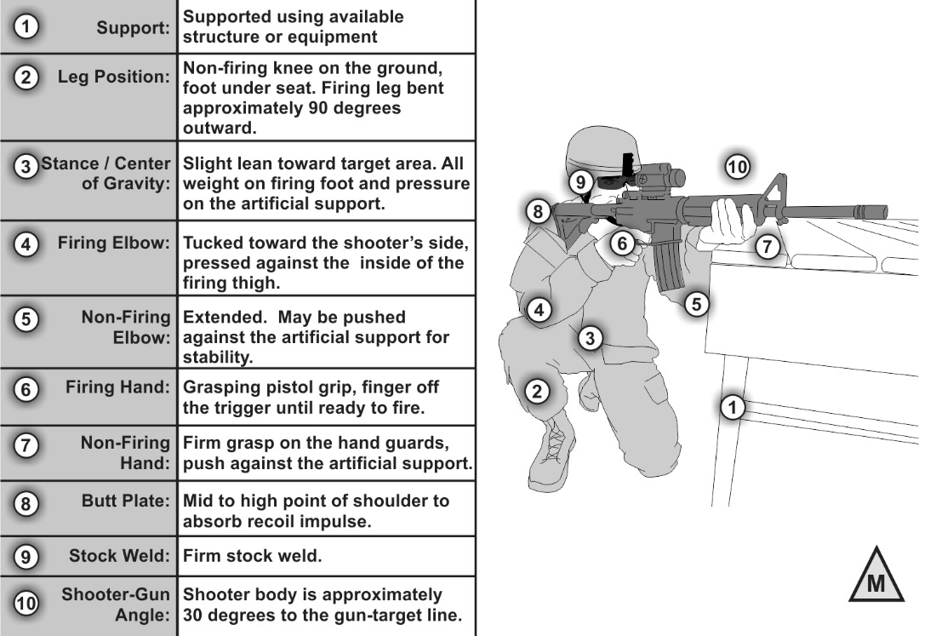

**Figure 6-13. Kneeling, supported example**

**SITTING, CROSSED-ANKLE**

6-43. The sitting, crossed-ankle position provides a broad base of support and places

most of the body weight behind the weapon (see figure 6-14). This allows quick shot

recovery and recoil impulse absorption. Perform the following to assume a good

crossed-ankle position:

-Face the target at a 10- to 30-degree angle.

-Place the non-firing hand under the hand guard.

-Bend at knees and break fall with the firing hand.

-Push backward with feet to extend legs and place the buttocks to ground.

-Cross the non-firing ankle over the firing ankle.

-Bend forward at the waist.

-Place the non-firing elbow on the non-firing leg below knee.

-Grasp the rifle butt with the firing hand and place into the firing shoulder pocket.

-Grasp the pistol grip with the firing hand.

-Lower the firing elbow to the inside of the firing knee.

-Place the cheek firmly against the stock to obtain a firm stock weld.

-Move the non-firing hand to a location under the hand guard that provides the maximum bone support and stability for the weapon.

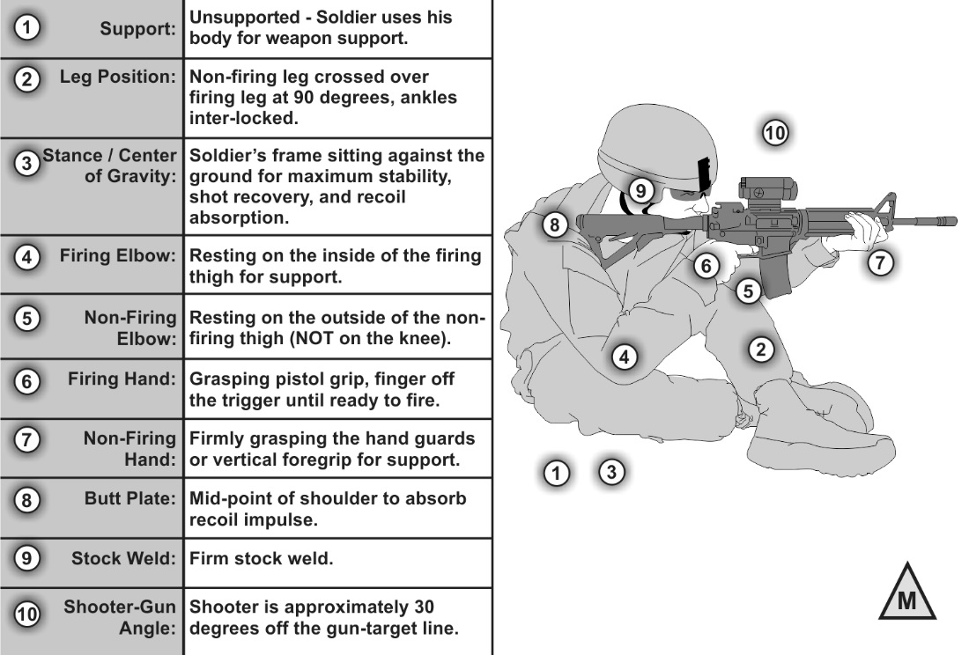

**Figure 6-14. Sitting position—crossed ankle**

**SITTING, CROSSED-LEG**

6-44. The crossed-leg sitting position provides a base of support and places most of the

body weight behind the weapon for quick shot recovery (see figure 6-15). Soldiers may

experience a strong pulse beat in this position due to restricted blood flow in the legs

and abdomen. An increased pulse causes a larger wobble area.

6-45. Perform the following to assume a good crossed-leg position:

-Place the non-firing hand under the hand guard.

-Cross the non-firing leg over the firing leg.

-Bend at the knees and break the fall with the firing hand.

-Place the buttocks to the ground close to the crossed legs.

-Bend forward at the waist.

-Place the non-firing elbow on the non-firing leg at the bend of the knee.

-Establish solid butt stock position in the firing shoulder pocket.

-Grasp the pistol grip with the firing hand.

-Lower the firing elbow to the inside of the firing knee.

-Place the cheek firmly against the stock to obtain a firm stock weld.

-Place the non-firing hand under the hand guard to provide support.

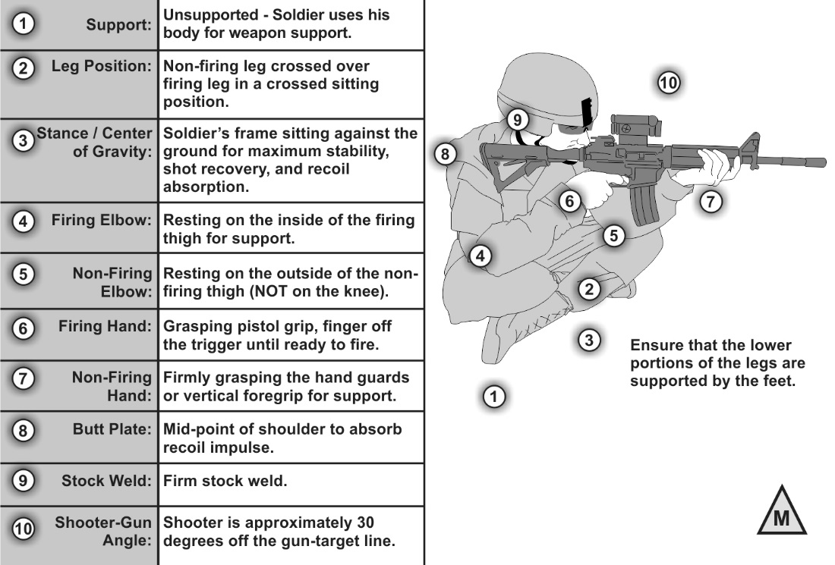

**Figure 6-15. Sitting position—crossed-leg**

**SITTING, OPEN-LEG**

6-46. The open-leg sitting position is the preferred sitting position when shooting with

combat equipment (see figure 6-16). It places less of the body weight behind the weapon

than the other sitting positions. Perform the following to assume a good open-leg

position:

-Face the target at a 10 to 30 degree angle to the firing of the line of fire.

-Place the feet approximately shoulder width apart.

-Place the non-firing hand under the hand guard.

-Bend at the knees while breaking the fall with the firing hand. Push backward with the feet to extend the legs and place the buttocks on ground.

-Place the both the firing and non-firing elbow inside the knees.

-Grasp the rifle butt with the firing hand and place into the firing shoulder pocket.

-Grasp the pistol grip with the firing hand.

-Lower the firing elbow to the inside of the firing knee.

-Place the cheek firmly against the stock to obtain a firm stock weld.

-Move non-firing hand to a location under the hand guard that provides maximum bone support and stability for the weapon.

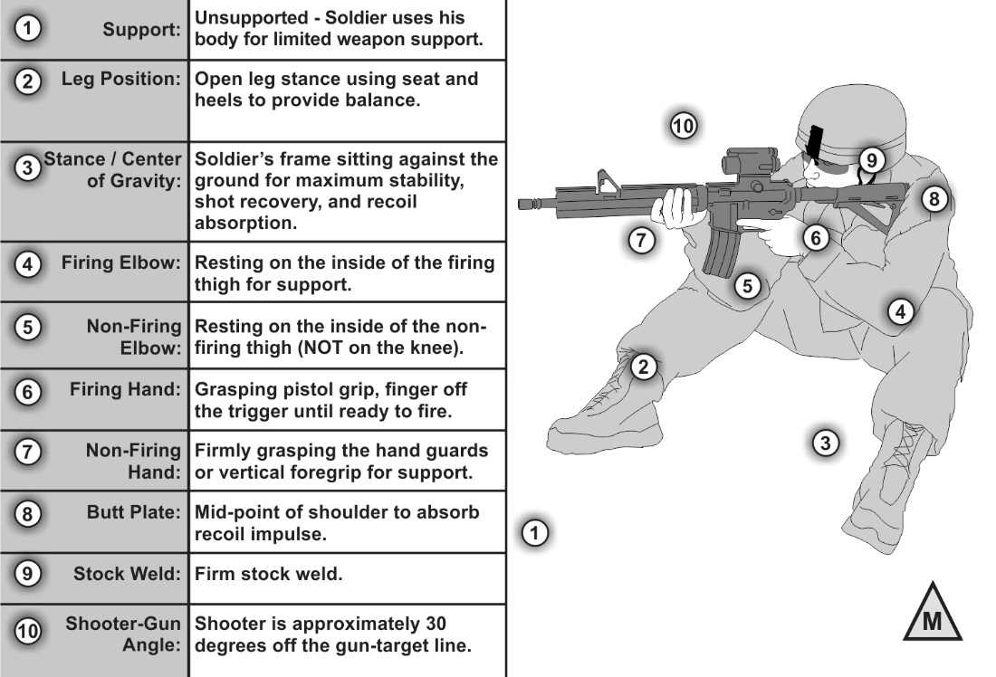

**Figure 6-16. Sitting position—open leg**

**PRONE, UNSUPPORTED**

6-47. The prone unsupported position is not as stable as the prone supported position

(see figure 6-17). Soldiers must build a stable, consistent position that focuses on the

following key areas:

-Firing hand. The firer should have a firm handshake grip on the pistol grip and place their finger on the trigger where it naturally falls.

-Non-firing hand. The non-firing hand is placed to control the weapon and is comfortable.

-Leg position. The firer’s legs may be either spread with heels as flat as possible on ground or the firing side leg may be bent at the knee to relieve pressure on the stomach.

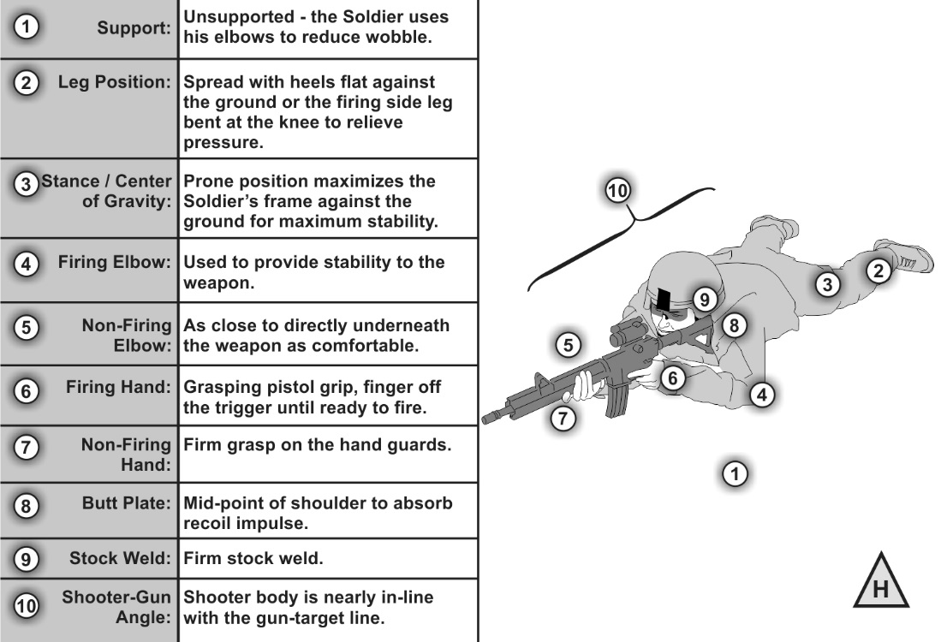

**Figure 6-17. Prone, unsupported example**

**Note. The magazine can be rested on the ground while using the prone unsupported position. Firing with the magazine on the ground will NOT induce a malfunction.**

**PRONE, SUPPORTED**

6-48. The prone supported position allows for the use of support, such as sandbags (see

figure 6-18). Soldiers must build a stable, consistent position that focuses on the

following key areas:

-Firing hand. The firer should have a firm handshake grip on the pistol grip and place their finger on the trigger where it naturally falls.

-Non-firing hand. The non-firing hand is placed to maximize control the weapon and where it is comfortable on the artificial support.

-Leg position. The firer’s legs may be either spread with heels as flat as possible on ground or the firing side leg may be bent at the knee to relieve pressure on the stomach.

-Artificial support. The artificial support should be at a height that allows for stability without interfering with the other elements of the position.

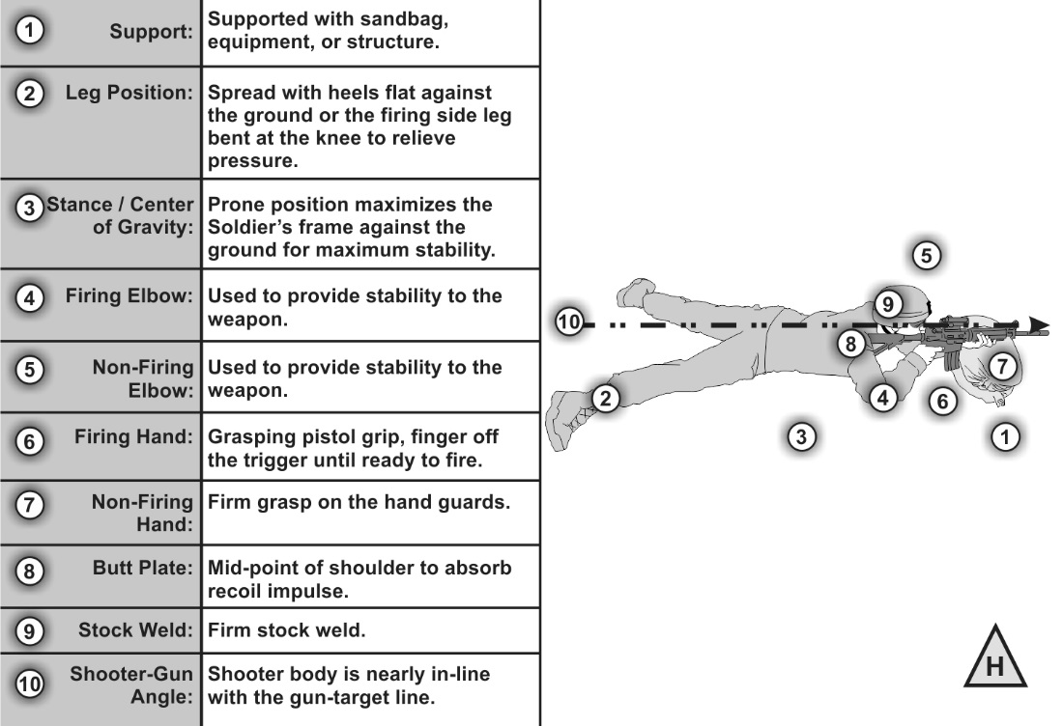

**Figure 6-18. Prone, supported example**

**PRONE, ROLL-OVER**

6-49. This position allows the firer to shoot under obstacles or cover that would not

normally be attainable from the standard conventional prone position (see figure 6-19).

With this position, the bullet trajectory will be off compared to the line of sight and

increase with distance from the firer.

For example, in the figure below the sights are rotated to the right. The

trajectory of the bullet will be lower than and to the right of point of aim. This

error will increase with range.

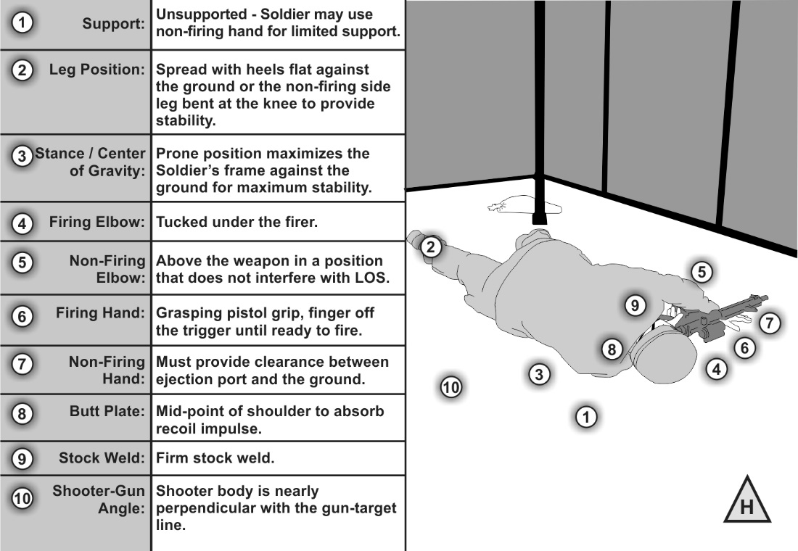

**Figure 6-19. Prone, roll-over example**

**PRONE, REVERSE ROLL-OVER**

6-50. This position is primarily used when the firer needs to keep behind cover that is

too low to use while in a traditional prone position (see figure 6-20). The bullet’s

trajectory will be off considerably at long distances while in this position.

6-51. This position is the most effective way to support the weapon when the traditional

prone is too low to be effective and where a kneeling position is too high to gain cover

or a solid base for support.

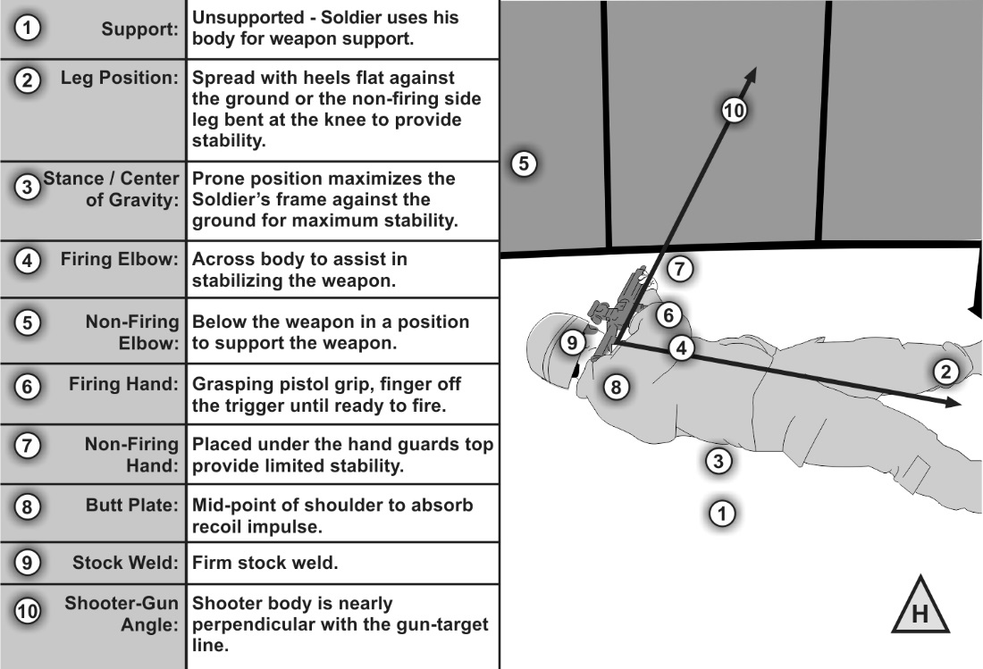

**Figure 6-20. Reverse roll-over prone firing position**