SAPPER LEADER COURSE
PAMPHLET

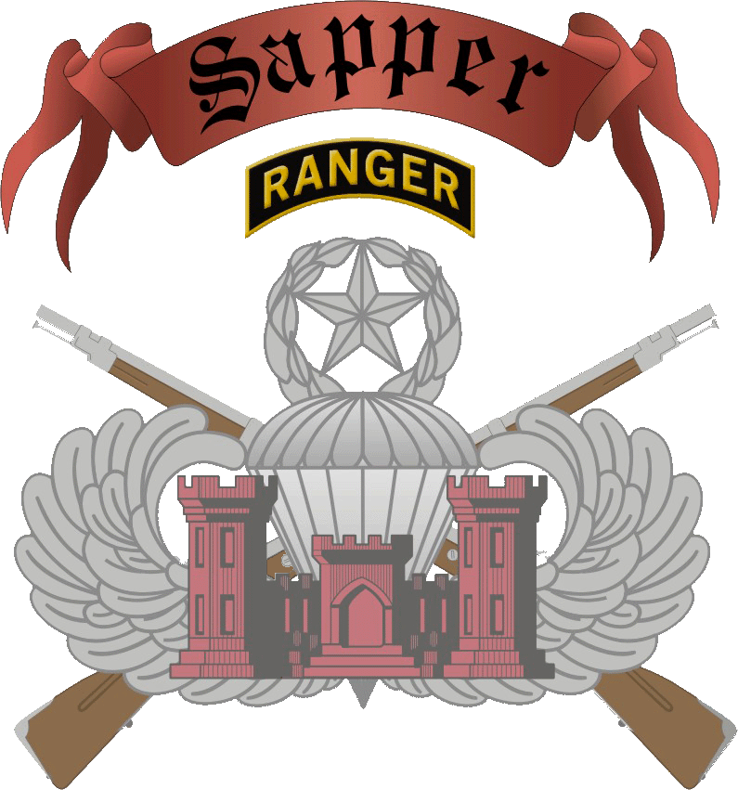

SAPPER TRAINING COMPANY (STC)
169th ENGINEER BATTALION
1ST ENGINEER BRIGADE
FORT LEONARD WOOD, MISSOURI 65473
Updated: 12JAN2022

THE SAPPER LEADER PAMPHLET

I. PREFACE 2
II. HISTORY OF THE SAPPER ENGINEER 3
III. OVERVIEW AND ATTENDANCE 4
MISSION 4
SCOPE 4
TRAINING LOCATION 4
PURPOSE 4
METHOD 4
ELIGIBILITY 4
PREREQUISITES 5
COMBAT WATER SURVIVAL TEST (CWST) 5
ATTENDANCE 5
REENTRY INTO COURSE 5
IV. STUDENT ORIENTATION 7
GENERAL 7
TRAVEL 8
MAILING ADDRESS 8
EMERGENCY PHONE CONTACT 8
LEAVE 8
REPORTING 8
MEDICAL requirements 9
MEDICATION 9
MEDICAL wAIVER REQUEST 9
BILLETING 10
MEALS 10
PAY 10
LAUNDRY SERVICES 10
TRAINING DAY 10
UNIFORM AND APPEARANCE 10
PHYSICAL FITNESS 10
SAPPER PHYSICAL FITNESS TEST 11
PHYSICAL FITNESS UNIFORM 11
DAILY PHYSICAL TRAINING 11
LEADERSHIP 11
V. EQUIPMENT AND HEADGEAR CONFIGURATIONS 12
VI. MANDATORY TRAINING 16
VII. INDIVIDUAL SOLDIER TASK PROFICIENCY 17

PREFACE
At the company level, mission success requires competent leaders capable of taking the initiative and acting independently in support of their higher commander's intent. Combat engineer leaders must be highly motivated, physically and mentally tough, and technically and tactically proficient in order to accomplish their missions and provide effective support to their maneuver elements. The Sapper Leader Course is designed to develop tough, hard, and knowledgeable leaders who are confident in their abilities and capable of operating under the harshest of conditions. The 28 day course is extremely fast paced and challenging. It will instill a high level of self-confidence and quickly enhance the cohesion within your unit. The primary focus of the Sapper Leader Course is troop leading procedures using dismounted combat patrolling as the teaching vehicle. The Sapper Leader Course is a leadership development school for combat engineers that teach skills critical to success on the battlefield. This pamphlet is designed to acquaint you with the Sapper Leader Course and the requirements for its successful completion.

The Sapper Leader Course is the premier leadership course for the Engineer Regiment. It trains confident and competent leaders to thoroughly plan and aggressively execute combat engineer missions. The training is challenging, but its rewards are great. Both individual Soldiers and units benefit from the training. Whether Sappers graduate or just complete the course, they return to home station with improved engineer and leadership skills which they can then pass on to their Soldiers.

There are two areas in which Soldiers must be proficient before attending the course; physical conditioning and the technical skills listed in section IX. Most of our attrition is due to inadequate physical conditioning and an inability to satisfactorily perform the aforementioned technical skills. A tough physical conditioning train-up as well as refresher training in the listed skills will improve performance and increase the Soldiers likelihood of graduation from the course.

HISTORY OF THE SAPPER ENGINEER
The term Sapper can be traced back as far as 1501 to the siege of Rouen during the French Wars. Sappers throughout time have proven their abilities to build and repair fortifications, execute field works, and reform the countryside with demolitions and heavy equipment to weaken the enemy and lead the infantry to victory on the battlefield.

On May 27, 1778, Congress authorized three companies of Sappers and Miners to receive instruction in erecting field works -- the first step toward technical education -- and to direct fatigue parties, repair damaged works and erect new ones. Recruitment continued for more than two years with the activation of the companies on August 2, 1780. Meanwhile, on March 11, 1779, Congress passed a resolution that formed the engineers of the Continental Army into the Corps of Engineers.

The Corps of Engineers and its companies of Sappers and Miners enjoyed their finest hour in October of 1781 at Yorktown where General Washington conducted a siege in the classical manner of Sebastian de Vauban, the great French master of siege craft. Thirteen engineer Officers of the combined French and American Armies performed crucial reconnaissance and with fifty men from the Sappers and Miners, planned and constructed field works. In addition, the Sappers and Miners assembled fortification materials, erected gun platforms, transported cannons and ammunition, and cleared the way for the decisive infantry assault on Redoubt 10. After the battle, General Washington cited Duportail, the first Chief of Engineers, for conduct which afforded "brilliant proofs of his military genius," and set the seal of his reputation.

Combat engineers in today's Army are required to demonstrate qualities similar to their Revolutionary War counterparts, and when they do, they proudly call themselves SAPPERS.

OVERVIEW AND ATTENDANCE

Mission
The Sapper Leader Course prepares and evaluates Engineer Leaders serving as a member of a Combined Arms team through training in small unit tactics and Combat Engineer Battle Drills in a physically demanding, stressful, and austere environment.

SCOPE
The Sapper Leader Course is a demanding 28 day leadership development course for combat engineers that reinforces critical skills and teaches advanced techniques needed across the Army. This course is also designed to build esprit de corps by training Soldiers in troop leading procedures, demolitions (conventional and expedient), and mountaineering operations. The course culminates in an intense field training exercise that reinforces the use of the battle drills and specialized engineer techniques learned throughout the course.

TRAINING LOCATION
The Sapper Leader Course is located at Fort Leonard Wood, Missouri which is in the vicinity of the Mark Twain National Forrest and the Lake of the Ozarks.

PURPOSE
To train combat engineers in leadership skills, combat engineer and infantry battle drills, and specialized engineer and infantry techniques required to perform as members of a Combined Arms Task Force; to build unit cohesion and increase the confidence of the unit’s leadership.

METHOD
The Sapper Leader Course is designed to train leaders from the squad level to the company level, (50 personnel per class). Training is conducted in a team building environment to build leadership skills, learn specialized engineer techniques, and perform battle drills necessary to perform the engineer missions of a Sapper Company. The course is also designed to build unit cohesion and esprit de corps by training the Soldiers in mobility, counter-mobility, and survivability tasks to include troop leading procedures, demolitions (conventional and expedient), mountaineering operations, aerial operations, airborne operations, foreign weapons, land navigation, waterborne operations, and contingency threat. The course culminates in an intense field training exercise that integrates the technical skills learned throughout the course in a tactical environment.

ELIGIBILITY
Army-Active, Reserve and National Guard Components:
12B, 12C and 12N - E4 through E7 (E3 with an approved rank waiver)
12A - O1 through O3
(E8 with approved rank waiver)

Marine Corps- Active, Reserve and National Guard Components:
1371 - E4 through E7
1302 - O1 and O2
ABC foreign allies are also approved to attend

Documents required:
-White Sheet (can be found on SLC website)
-1610/Orders (All students must have orders to attend SLC regardless if they are from FLW)
-Soldier/Officer Records Brief (SRB/ORB) dated within 30 Days of Class start date
-DA 705 (PT Card) (w/ 5500/5501) that qualified individual for SLC
-Battalion Commander Certification Letter
-Sapper, Ranger or Airborne physical (copy, not original)

Qualification tasks:
Day 0, Sapper Physical Fitness Test (SPFT) - (HRPU, LT, & 3 Mile Run)
- Hand Release Push-ups min 30 reps
- Leg Tucks min 5 reps
- 3 Mile run in under 24 minutes

PREREQUISITES
All Sapper Leader Course students must meet the required standards of the Sapper Physical Fitness Test (SPFT), executing a minimum of 30 repetitions of Hand Release Push-ups, 5 repetitions of Leg Tucks, and run 3 miles in under 24 minutes. If a Soldier cannot pass all events, they will be denied enrollment even if they have a reserve slot in ATRRS.

COMBAT WATER SURVIVAL TEST (CWST)
All students must conduct Combat Water Survival Testing prior to arrival. Students must have their swimming ability identified (strong/weak/non-swimmer) on the Battalion Commanders proficiency certification memorandum. The CWST is administered IAW TC 21-21 Combat Water Survival Training. While passing the CWST is not required for attendance, it is required to identify weak and non-swimmers. Additionally, a poncho raft swim in open water is a graded event during the course. Weak and non-swimmers will struggle with this event. Consequently, it is recommended that they practice swimming prior to attending the course. The CWST will not be conducted at the Sapper Leader Course. All students must have at least attempted the CWST before attending Sapper Leader Course.

ATTENDANCE
Individual course allocation requests must be submitted through the Army Training Requirements and Resources System (ATRRS). Walk-ons are accepted to all classes! Walk-on students will be put onto an Order of Merit List based on their SPFT scores. All students should be in peek physical condition, be proficient in all 10 level tasks in this pamphlet, have all required documents, and be able to meet all prerequisites and entrance requirements.

REENTRY INTO COURSE
Release from the Sapper Leader Course for misconduct or refusal to train requires a waiver from the first O6 (COL) level Commander in the Soldier’s chain of command for the Soldier to return to the course. The Soldier can return no earlier than six months after dismissal. Soldiers attempting to get into the course without the waiver will be denied enrollment and/or dropped from the course.

Medical drops may return to the course once cleared by a physician, and when their unit deems them physically ready to attend the course.

Effective April 2016, all recycle eligible students will be automatically recycled into the next Sapper class. There are only two authorized automatic recycle categories in the Sapper Leader Course: General Subjects Recycle and Patrolling Recycle.

- General Subjects Recycle: Any first time General Subjects student who earns less than 700 points, fails both opportunities to pass land navigation, or fails both opportunities to pass any written exam will become an automatic General Subjects Recycle. Or a student can be recycled by the Sapper Command Team to try to prevent a negative DA Form 1059.

- Patrolling Recycle: Any first time Patrolling student that does not achieve a GO rate while in graded positions will become an automatic Patrolling Recycle. They may be recycled by the Sapper Command Team to prevent a negative 1059.

Exception to Policy Requests: Sapper students who automatically recycle could be assigned to the Sapper Leader Course for up to 70 days to complete the recycle phases (two tries at General Subjects phase, and two tries at Patrolling phase). Home station Battalion Commanders may request an exception to policy (ETP) approved through the Sapper Leader Course to the 1st Engineer Brigade Commander and approved by Commandant, USAES forgoing their SM’s eligibility to automatically recycle. All recycle ETPs must be approved prior to the report date of the class and included in the student’s in processing packet on day zero.

STUDENT ORIENTATION

GENERAL
The following information is intended to provide answers to typical questions posed by prospective Sapper Leader Course students.

The Sapper Leader Course is a demanding 28-day course designed to train leaders from the squad level to the company level, (32-50 students per class). Training is conducted in a team building environment in order to build leadership skills, learn specialized engineer techniques, and perform battle drills necessary to execute engineer missions. The course is organized into two phases: Phase I - General Subjects; Phase II - Patrolling

Phase I. This phase lasts 13 days. It includes general subjects such as:
- Physical Training
- Engineer Recon
- Mobility / Counter-Mobility
- Engagement Area Development
- Demolitions Training (conventional and expedient)
- Urban Breaching
- Threat Ordnance
- Land Navigation
- Knots and Rigging
- Air Operations (aerial resupply and landing zone, pick-zone, and drop zone operations)
- Mountaineering
- Water Operations (scout swimming, boat operations, river crossings, and helocasting techniques).

Phase II. This phase lasts for 15 days. It includes basic patrolling techniques and battle drills that place strong emphasis on troop-leading procedures, battle drills, planning for operations, and small-unit operations. It incorporates the technical skills learned in GS into a tactical environment. Training includes:

- Patrol Organization and Movement
- Intelligence
- Recon/Raid/Ambush
- Operation Order
- Warning Order
- Fragmentary Order
- MOUT
- Breaching Tenants
- Troop Leading Procedures
- 8 Day Field Training Exercise

FTX: This is a continuous 8 day field training exercise. Student leadership is rotated during different phases of the mission which requires students to perform in simulated combat situations to accomplish a variety of missions in a realistic scenario. Students are graded on their ability to apply the principles of patrolling to accomplish the mission. Missions conducted during the STX/FTX are a mix of engineer and infantry missions with a focus on the Engineer tasks (MOB/CMOB/SURV) required to accomplish the mission. Engineer specific missions include: bridge reconnaissance, bridge demolition, road craters, covert complex obstacle breach, urban reconnaissance, and field expedient demolitions.

TRAVEL
Incoming students should either arrange round trip transportation to and from Fort Leonard Wood; or fly into St. Louis and arrange transportation to and from Fort Leonard Wood. There are only two commercial flights daily to and from Waynesville Regional Airport, Fort Leonard Wood. Some flights may carry only 19 passengers and have limited baggage capability.

Students may take a POV to the course. However, once the course starts they will not have access to the vehicle and are liable for anything left in the vehicle during the 28-day course. It is highly discouraged that units authorize rental cars to students while on TDY to the course. Units should also make authorizations for early return on the students travel orders in case they must return to the home duty station prior to the graduation date. These students may include medical drops and emergency leaves.

MAILING ADDRESS
Sapper Leader Course students can use the following mailing address:

Rank, Name,
741 Iowa Ave
ATTN: Sapper Leader Course, Class # ________
Sapper Leader Course, 169th Engineer Battalion
Fort Leonard Wood, Missouri 65473-6400

EMERGENCY PHONE CONTACT
The telephone number for emergency contact during duty hours (0900-1700 CST Mon-Fri) is the Sapper OPS at (573) 596-0823. After duty hours the 1st Engineer Brigade SDO telephone number is (573) 596-0222. The installation Defense Switching Network (DSN) prefix is 581.

LEAVE
Only emergency leave will be granted, as determined by the unit commander, and may result in administrative release from the course. DA Form 31 and a Red Cross message (if applicable) must be sent to Sapper OPS from Students originating unit before student will be released. The Sapper Training Company Commander will not be the approving authority for any Students leave except during Holiday Block leave periods.

REPORTING
All incoming students must report to Building 6105 Minnesota Ave, Fort Leonard Wood, Missouri and sign-in on the Thursday prior to the course start date. In-processing will run from 1300-1500 inside Building 6105. Students must have the required documents in hand. Then, they must report to TA-106 NLT 0430 on the course start date. Building 6105 is located approx. 3 miles from the main gate of FLW. Take the first right (Indiana Avenue) after entering post and remain on Indiana Avenue for approximately three miles until you reach Minnesota Ave and then take a right onto Minnesota Ave. Follow the road around until you see Building 6105. Students may drop their bags at the barracks and then park at TA-106, which is the PT Bubble located on Indiana Avenue just south of the Sapper Leader Course HQ/Barracks. For further information, the Visitor Information building is located at the main entrance to post. It is highly recommended that students arrive on the Thursday before the course start date.
Sapper Training Company will not provide transportation to and from the airport.

Students should report to the Sapper Leader Course NET 1300 and NLT 2100 on their report date (Thursday).

Incoming Sapper Leader Course students will have in their possession:
- All equipment on the packing list (Note: pay attention to “Winter Class” items)
- White Sheet
- DA Form 1610/TAD orders, include statement of early return in event of drop
- SRB/ORB dated within 30 days of class start date
- DA 705 (PT Card) (w/ 5500/5501)
- Ranger/Sapper/Airborne qualified Physical Dated within 12 months of course start
- Battalion Commanders Certification Letter signed by the first LTC in your COC

MEDICAL requirements
A COPY of the physical examination must accompany the student to the course; all three pages for the 2807, 2808 and supporting documents. The exam must be dated within 18 months of the report date, and state the applicant is medically qualified to attend. The exam record must include blood work (CBC/DIFF and UA Kidney function). Your medical facility may refer to this as “Ranger, Sapper, and Airborne Physical.” Dental records must include a memorandum from the dentist stating a full mouth x-ray/panorex exists at home station and is available by contacting the home unit, if requested or block 83a is signed and stamped by a Dentist.

All students are required to hand-carry (recommend a copy not original) physical and a panorex dental memorandum to the course. If block 83a is signed and stamped by a Dentist on the physical, a panorex dental memorandum is not needed. Records are turned in to the Senior Medic during in-processing. Medical questions can be answered by calling the course medic prior to the report date at (573) 563-3201. Students who arrive with incomplete physicals will be denied entry into the course.

MEDICATION
Per AR 40-501: The Standards of Medical Fitness, Chapter 5, “individuals who are under treatment with any mood-ameliorating, tranquillizing, or ataraxic drugs for hypertension, angina pectoris, nervous tension, instability, insomnia, and so forth, and for a period of 4 weeks after the drugs has been discontinued” and students who show “Evidence of excessive anxiety, tenseness, or emotional instability. Fear of dark or enclosed spaces, fear of heights” are denied enrollment to the Sapper Leader Course.

No supplements are authorized at the Sapper Leader Course. It is recommended that you stop taking supplements two weeks prior to arrival so that it gets out of your system. Failure to do so could cause you to become a medical drop from the course and put you at greater risk of becoming a hot/cold weather casualty.

MEDICAL wAIVER REQUEST
In order to request a medical waiver you must forward a copy of your completed physical, with disqualifying factors annotated, to the course inbox with a waiver recommendation from your provider in block 78. Once received, your physical and waiver request will be vetted by the Course physician and approved or denied by the Commander.
If you PCM is not comfortable recommending a waiver in block 78 your waiver will not be granted.

BILLETING
All personnel are billeted in the 35th Engineer Battalion footprint in Building 6105 located at the intersection of FLW 20 and Minnesota Ave, 1/2 mile from the Sapper Leader Course classroom. During the Patrolling Phase of the course, students live and operate in a field environment at FOB Falaniko.

MEALS
All students eat in a dining facility or mermites when not participating in field operations at no cost to the student.

PAY
The parent unit Finance & Accounting Office administers all financial matters to include monthly pay and travel pay. Only emergencies will be handled at Fort Leonard Wood. Students need only bring sufficient funds to pay for expenses such as incidentals and personal needs (~$100.00). Cash or traveler’s checks are recommended, time will only be given to use an ATM at the end of the course. Students are required to pay for any government equipment lost or damaged during the course. Statements of charges and cash collection vouchers are accepted.

LAUNDRY SERVICES
Washers, dryers, and hand washing facilities are available at the Sapper Leader Course for student use at no charge.

TRAINING DAY
The normal training day is from 0500 to 2200 hours, seven days a week. The last 14 days are spent in the field conducting 24 hour operations.

UNIFORM AND APPEARANCE
The uniform and appearance of all personnel must comply with AR/DA PAM 670-1. There will not be an opportunity to get a haircut during the course; Soldiers must arrive at in-processing with a fresh haircut that will not become out of regulation for the duration of the course. All uniforms must be in serviceable condition. "Lead By Example".

PHYSICAL FITNESS
All personnel must arrive in excellent physical condition. Physical Training is conducted each training day. This will be followed by 14 hours of rigorous training that is as demanding as the PT session. Physically weak students are at a higher risk of failing the course due to the likelihood of injury. Feet, knee, and ankle injuries are prevalent due to extensive walking. Training before arriving at the Sapper Leader Course should be conducted with this in mind.

Physical Condition: All commanders must ensure that candidates are in top physical condition when reporting to the Sapper Leader Course. Applicants should concentrate on improving upper body strength and foot marching in properly fitted boots, with a full pack (40 lbs) for distances of at least 12 miles over varied terrain (i.e. steep grades) in three hours or less. Historically, those scoring less than a 230 on the APFT graduate at half the rate of personnel who score above 275 and are 7 times more likely to be medically dropped from the course.

SAPPER PHYSICAL FITNESS TEST
The cadre will administer the Sapper Physical Fitness Test (SPFT) to all students. All Sapper Leader Course students must meet the required standards of the Sapper Physical Fitness Test (SPFT), executing a minimum of 30 repetitions of Hand Release Push-ups, 5 repetitions of Leg Tucks, and run 3 miles in under 24 minutes. Soldiers must meet the Army height and weight standards IAW AR 600-9 upon reporting to the course.

PHYSICAL FITNESS UNIFORM
Summer: (May - September): The PT uniform is the Army black shirt, black shorts, white or black socks, and athletic shoes IAW AR 670-1 with road guard vest (provided) and flashlight/ and or chemlight. No unit distinctive T-shirts are authorized. Sister Service candidates will wear their uniform equivalent; shorts, t-shirt, athletic shoes, and white socks.

Winter: (October - April): The PT uniform is the Army black jacket, black pants, black fleece cap, black gloves, green wool glove liners in addition to the Summer PT uniform IAW AR 670-1 with road guard vest and flashlight/ and or chemlight. Sister Service candidates will wear their uniform equivalent; summer uniform with sweat shirt, sweat pants, fleece cap, and green gloves.

DAILY PHYSICAL TRAINING
During daily physical training, students must earn points by completing the callisthenic exercises and distance run(s) with the cadre leader for that day. Students who exhibit poor physical conditioning or do not complete the run(s) will not receive the allocated points for that PT session.

A typical physical training session during the first 2 weeks may include:
- Several exercises working both upper and lower body to muscle failure.
- Distance run of 3 - 7 miles, at an 8-minute per mile pace. Runs may conducted in formation.
- Foot March: All personnel will complete a 12-mile foot march, with weapon, LBE/FLC/LBV/TAPS and 35 pound pack not including water weight within 3 hours.

LEADERSHIP
The Sapper Leader Course develops the leadership skills of the students by requiring them to perform effectively as small unit leaders in an austere and realistic tactical environment. During the first phase, the leadership positions are rotated daily. During Phase II, the leadership positions are rotated daily and after each mission.

Throughout the course, the "buddy system" is used to instill a spirit of teamwork and cooperation. Each student is responsible for knowing his buddy's location and watching out for his or her welfare.

Each student will be evaluated a minimum of two times on leadership during patrolling and must receive a "GO" in one of these evaluations.

The Sapper Leader Course develops hardened combat engineers that are better prepared to fight on today's modern battlefield with increased leadership skills.

EQUIPMENT AND HEADGEAR CONFIGURATIONS

FLC/TAPS

THE FOLLOWING ITEMS MUST BE ON FLC/TAPS
7x Magazines, 2x 1 QT Canteens w/ pouches, IFAC with components, Additional pouch, Ear Pro, Whistle, Compass

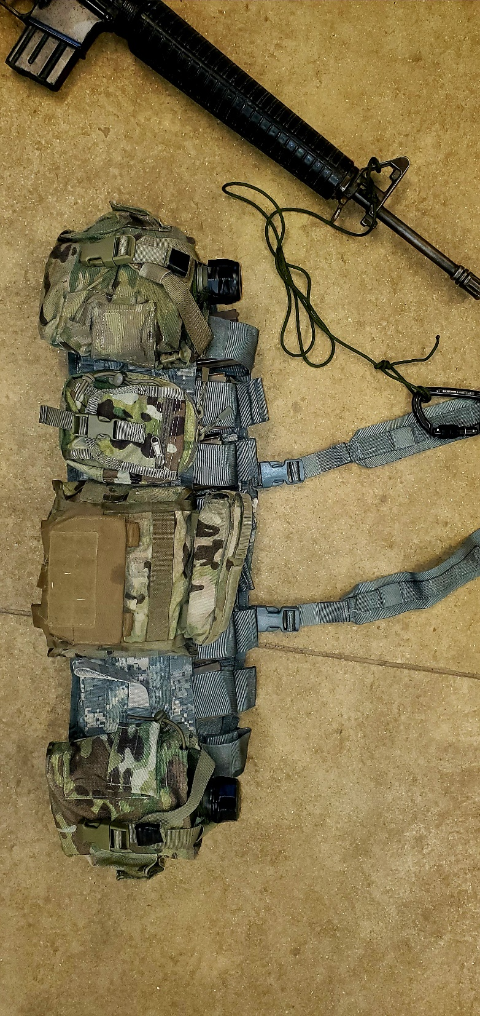

ALICE PACK
- E-Tool cover & 2 Qt canteen cover are secured to the ALICE pack using gutted 550-cord tied with a square knot and two overhands.
- 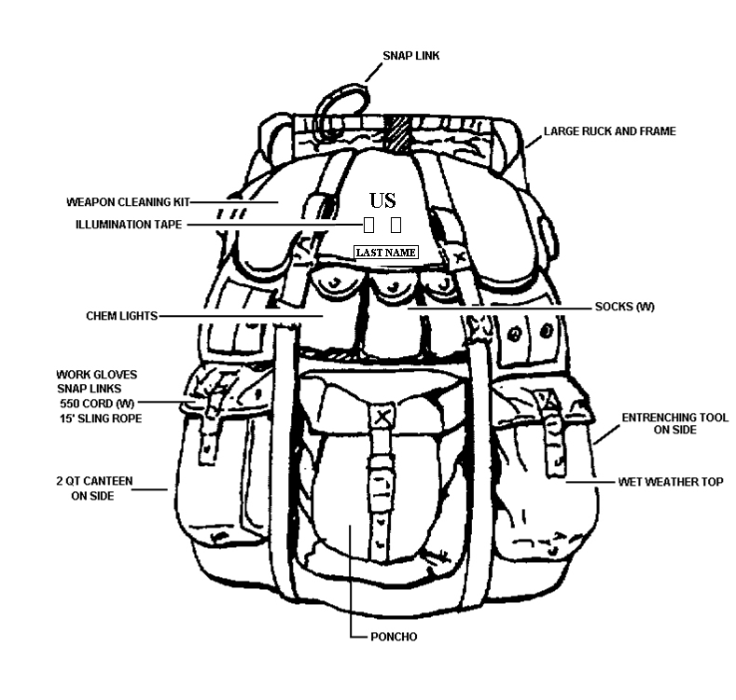The E-Tool and 2 Qt canteen are further secured with a Sapper assist cord. Each item is secured with an end of the line bowline with overhand safety and the other end of the assist cord is secured to the ALICE pack itself with an end of the line bowline and overhand safety.
NAME TAPE
ON TOP OF WATERPROOF BAG | IN WATERPROOF BAG | MAP POCKET
Kevlar/ACH | Patrol Cap | Socks x1 (W)
Mission Essential Equipment | ACU/Cami Pant x1 | Camouflage Stick
MRE’s | ACU/Cami Top x1 | Insect Repellent
100 MPH Tape (W) | T-Shirt x2 | Razor
Electrical Tape (W) | ECWCS Level 1 Top x1  ECWCS Level 1 Bottom x 1 | Soap  Head Lamp
 | Poncho Liner | Towel
 | Combat Boots x1 | Protractor
 | Socks x1 | Map Markers
 | Poly Pro Top (Winter) | Calculator (W)
 | Cold Weather Gloves (Winter)
 | Fleece Cap (Winter)

MOLLE PACK
- E-Tool cover & 2 Qt canteen cover are secured to the MOLLE pack using gutted 550-cord tied with a square knot and two overhands.
- The E-Tool and the 2 Qt canteen are further secured with a Sapper assist cord. Each item is secured with an end of the line bowline with overhand safety and the other end of the assist cord is secured to the MOLLE frame with an end of the line bowline and overhand safety.
- The Marine ILBE will be configured in the same manner except, the gear in the side sustainment pouches will be placed in the top flap pouch.

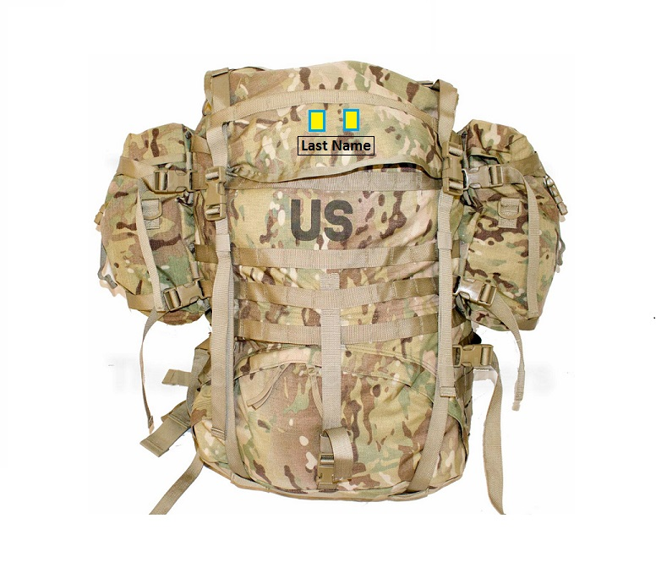
Right Side Sustainment Pouch
Name Tape
ILLUM Tape
E-Tool on right side as worn
2 QT Canteen on left side as worn
Left Side Sustainment Pouch

ON TOP OF WATERPROOF BAG | IN WATERPROOF BAG | MAP POCKET | LEFT SIDE SUSTAINMENT POUCH | RIGHT SIDE SUSTAINMENT POUCH
Kevlar/ ACH | Patrol Cap | Socks x1(W) | Rappel Gloves (W) | Socks x1(W)
Mission Essential Equipment | ACU/Cami Pant x1 | Sapper Handbook | Carabineers (W) | Chemlights
MRE’s | ACU/Cami Top x1 | Insect Repellent | 15’ Sling Rope (W) | Wet Weather Top
Sun Screen | T-Shirt x2 | Razor | 6’ 550 Cord (W) | Poncho/Tarp
 | Black Gloves | Soap | Climbing Harness | Camouflage Stick
 | Poncho Liner | Towel | ATC | 100 MPH Tape (W)
 | Combat Boots | Protractor | Rescue 8 | Electrical Tape (W)
 | Wool Socks x1 | Map Markers | Pre-Sewn Runner | Tape Measure
 | ECWCS Level 2 xTop (Winter) | Calculator (W)  Head Lamp (W) |  | ECWCS Level 1 Top
 | Cold Weather Gloves (Winter)  ECWCS Level 1 Bottom | Hearing Protection (W)
 | Fleece Cap (Winter)

- All items worn on the LBE/FLC/LBV/TAPS are secured either with MOLLE webbing or with gutted 550-cord tied with a square knot & two overhand knots (i.e. first aid pouch, ammo pouches, canteen covers, etc.). The LBE/FLC/LBV/TAPS needs to be configured to carry at a minimum, six magazines, two canteen pouches, IFAK, NVG pouch, and compass pouch. Morale patches are not authorized.

- Items such as knives, canteen cup, canteens, and flashlight have a Sapper assist cord fastened to the item with an end of the line bowline safetied with an overhand knot. The other end of the gutted 550-cord is tied to the web belt with an end of the line bowline safetied with an overhand knot.
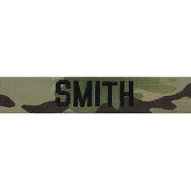
Normal Weak Previous Cold / Weak Swimmer/
Student Swimmer Heat Injury Previous Cold /
Heat Injury

- Soft cap/Cover with name tape and illuminous tape 1” x 1/2” with at least 12 independent stitches on each piece of illuminous tape.

NOTES: ALL ITEMS WILL BE BROUGHT WITH YOU FROM HOME STATION.
No CIF facilities are available for the use of Sapper students. It is suggested that the Soldier bring serviceable equipment and gear sufficient enough to last the duration of the course. Most commonly damaged items include ALICE/MOLLE packs and frames, shoulder straps, compasses, ponchos, headlamps, gloves, and 2 quart canteens.

*Winter items must be brought from mid-August to 30 April. (Potential to recycle and stay up to 70 days could result in you being recycled into a winter class)

MANDATORY TRAINING
Successful completion of the following training is a prerequisite for graduation:

Day/Night Land Navigation Course: GO/NO GO **

12 Mile Road March: GO/NO GO **

Demolitions Written Exam: GO/NO GO **

Air Operations Exam: GO/NO GO **

Engagement Area Development Exam: GO/NO GO **

Urban Mobility Breaching Exam: GO/NO GO **

Leadership Grades: GO/NO GO ***
(Receive go on 50 percent of grades)

Overall Points: GO/NO GO (Receive 70% of points available)

Participate in all training: GO/NO GO ****
(Students can only miss 24 hours of training in 28 days of training)

NOTES:
*Not meeting the height and weight standards, failing the SPFT will result in denial of enrollment to the course and return to the unit's home station regardless of ATRRS reservation.

**One re-test authorized.

***Leadership evaluations will be done IAW the Sapper Leader Course Patrolling Evaluation Book and recorded on the Leader Evaluation Form.

****Individuals who refuse to participate in any training event will be counseled, removed from all training, receive a negative 1059 (AER), and remain at Sapper Leader Course until out-processed.

INDIVIDUAL SOLDIER TASK PROFICIENCY
Students must be proficient in the following tasks prior to attending the Sapper Leader Course. By clicking on the hyperlink you will be transferred to the Combined Arms Training Strategies (CATS) page of the Army Training Network (ATN) website. On that page you will be able to search for tasks by title or by the task number.

TITLE (TASK NUMBER)

Detect Explosive-Hazard Indicators by Visual Means (052-192-1269)
Construct Demolition Firing Systems (052-193-1310)
Prime Military Explosives (052-193-1311)
Construct Demolition Initiating Systems (052-193-1312)
Identify the Characteristics of Military Demolitions and Explosives (052-193-1313)
Place Steel-Cutting Charges (052-193-1317)
Place Breaching Charges (052-193-1318)
Place Cratering Charges (052-193-2018)
Move as a Member of a Team (071-COM-0501)
Operate Night Vision Device, AN/PVS-14 (071-706-0001)
Maintain an M240B Machine Gun (071-025-0001)
Perform a Function Check on an M240B Machine Gun (071-025-0002)
Maintain an M249 Machine Gun (071-COM-4025)
Perform a Function Check on an M249 Machine Gun (071-COM-4026)
Employ an M18A1 Claymore Mine (071-325-4427)
Initiate a 9-Line Medevac Request (081-833-0283)
Analyze Terrain (071-331-0820)
Determine the Elevation of a Point on the Ground Using a Map (071-329-1004)
Convert Azimuths (071-329-1009)
Orient a Map Using an M2 Compass (071-520-0001)
Locate an Unknown Point on a Map and on the Ground by Intersection (071-329-1014)
Locate an Unknown Point on a Map and on the Ground by Resection (071-329-1015)
Determine the Grid Coordinates of a Point on a Military Map (071-COM-1002)
Operate the RT1523E SINCGARS ASIP Radio (171-300-0063)

NOTE: In addition to proficiency in these Soldier tasks, all Soldiers must be proficient in all Tasks in STP 5-12B1-SM: MOS 12B, Combat Engineer Skill Level 1

The following FM’s and STP’s will be helpful to students preparing to attend the course:

Overall Course:
- STP 5-12B1-SM: MOS 12B, Combat Engineer Skill Level 1
- STP 5-12B24-SM-TG: MOS 12B, Combat Engineer Skill Levels 2/3/4
- STP 21-1-SMCT Soldier’s Manual of Common Tasks Level 1
- STP 21-24-SMCT Soldier’s Manual of Common Tasks Levels 2/3/4
- TM 3-34.85: Engineer Field Data
- TC 3-34.85 Sapper Leader Course Handbook
- FM 7-22: Army Physical Readiness Training

General Subjects:
- Fieldcraft:
  - TC 4-02.1: First Aid
- Threat:
  - ATP 3-90.37: Countering Improvised Explosive Defeat
  - ATP 3-34.20: Countering Explosive Hazards
- Air Operations:
  - FM 3-21.38: Pathfinder Operations
  - TM 4-48.10: Multi-Service Helicopter Sling Load Single Point Load Rigging
- Mountaineering:
  - TC 3-97.61: Military Mountaineering
  - TC 21-24: Rappelling
- Demolitions:
  - TM 3-34.82: Explosives and Demolitions
Patrolling:
- ADP 3-90: Offensive and Defensive Tactics
- ADP 5-0: The Operations Process
- ATP 3-90.8: Combined Arms Counter-mobility Operations
- ATTP 3-90.4: Combined Arms Mobility
- ATP 3-34.81: Engineer Reconnaissance
- ATP 3-21.8: Infantry Platoon and Squad
- ATP 3-09.30: Observed Fire
- FM 3-22.9, FM 3-22.68
- TM 3-34.82: Explosives and Demolitions

